Responsive Care and Early Learning Addendum

Counseling Cards

September 2023

About USAID Advancing Nutrition
USAID Advancing Nutrition is the Agency’s flagship multi-sectoral nutrition project, led by JSI Research & Training Institute, Inc. (JSI), and a diverse group
of experienced partners. Launched in September 2018, USAID Advancing Nutrition implements nutrition interventions across sectors and disciplines for USAID and its partners. The project’s multi-sectoral approach draws together global nutrition experience to design, implement, and evaluate programs
that address the root causes of malnutrition. Committed to using a systems approach, USAID Advancing Nutrition strives to sustain positive outcomes
by building local capacity, supporting behavior change, and strengthening the enabling environment to save lives, improve health, build resilience, increase economic productivity, and advance development.

Disclaimer
These cards are made possible by the generous support of the American people through the United States Agency for International Development
(USAID). The contents are the responsibility of JSI Research & Training Institute, Inc. (JSI), and do not necessarily reflect the views of USAID or the
United States government.

Recommended Citation
USAID Advancing Nutrition. 2023. Responsive Care and Early Learning Addendum: Counseling Cards. Arlington, VA: USAID Advancing Nutrition.
Image Credit: Víctor Nolasco for JSI
Layout: Sydney Tawanda Mukonoweshuro for JSI

USAID Advancing Nutrition
JSI Research &Training Institute, Inc.
2733 Crystal Drive
4th Floor
Arlington, VA 22202

Phone: 703-528-7474
Email: info@advancingnutrition.org
Web: advancingnutrition.org

Table of Contents
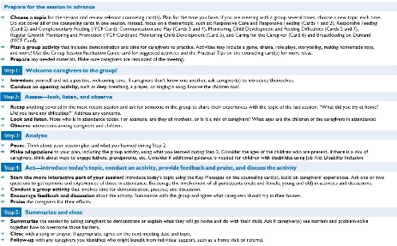
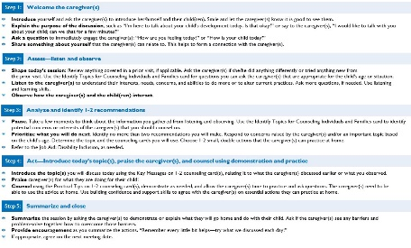
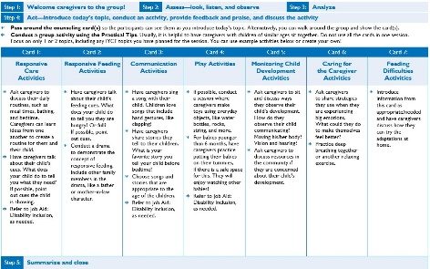
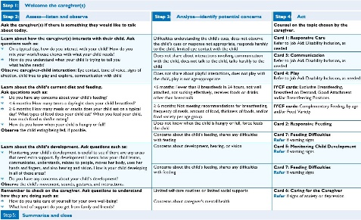
Steps for Facilitating Group
Sessions
Job Aid: Group Sessions
Steps for Counseling Individuals
and Families
Job Aid: Individual Counseling
Group Session Facilitation Guide
Job Aid: Group Sessions
Identify Topics for Counseling
Individuals and Families
Job Aid: Individual Counseling
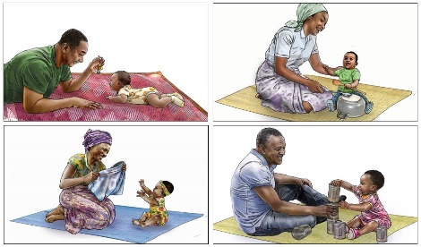
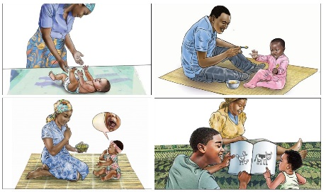
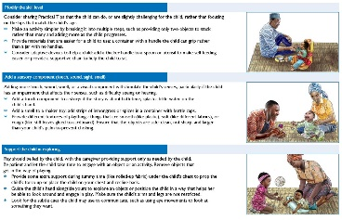
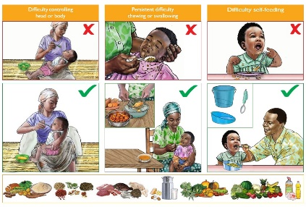
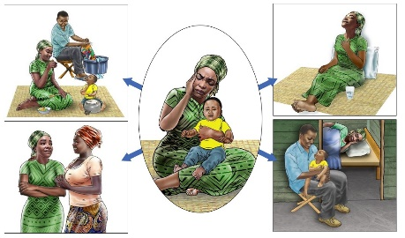
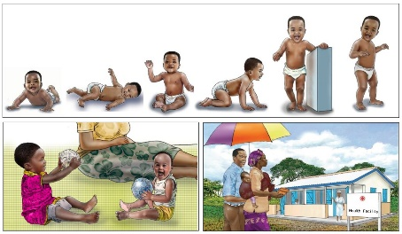
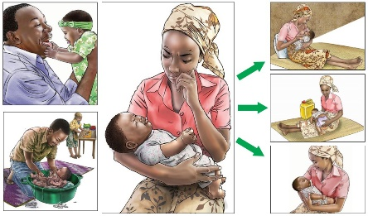
Listen and talk to your child all
the time
Card 3: Communication
Give your child daily opportunities
to learn through play
Tips for Supporting Children with Disabilities to Engage in Play
and Learning
Job Aid: Disability Inclusion
Care and feeding for children with
feeding difficulties
Special Circumstances Card 7: Feeding Difficulties
Take care of yourself in order to care
for your child
Card 6: Caring for the Caregiver
Seek help if you are concerned
about your child’s development
Card 5: Monitoring Child Development
Teach your child to eat with love,
patience, and good humor
Card 2: Responsive Feeding
Your loving care helps your child
grow and develop
Card 1: Responsive Care
Card 4: Play

Steps for Counseling Individuals and Families
Welcome the caregiver(s)
Step 1:
- Introduce yourself and ask the caregiver(s) to introduce her/himself and their child(ren). Smile and let the caregiver(s) know it is good to see them.
- Explain the purpose of the discussion, such as “I’m here to talk about your child’s development today. Is that okay?” or say to the caregiver(s), “I would like to talk with you about your child; can we chat for a few minutes?”
- Ask a question to immediately engage the caregiver(s): “How are you feeling today?” or “How is your child today?”
- Share something about yourself that the caregiver(s) can relate to. This helps to form a connection with the caregiver(s).
Assess—listen and observe
Step 2:
- Shape today’s session: Review anything covered in a prior visit, if applicable. Ask the caregiver(s) if she/he did anything differently or tried anything new from
the prior visit. Use the Identify Topics for Counseling Individuals and Families card for questions you can ask the caregiver(s) that are appropriate for the child’s age or situation.
- Listen to the caregiver(s) to understand their interests, needs, concerns, and abilities to do more or to alter current practices. Ask more questions, if needed. Use listening
and learning skills.
- Observe how the caregiver(s) and the child(ren) interact.
Analyze and identify 1-2 recommendations
Step 3:
- Pause. Take a few moments to think about the information you gathered from listening and observing. Use the Identify Topics for Counseling Individuals and Families card to identify potential concerns or interests of the caregiver(s) that you should counsel on.
- Prioritize what you will do next. Identify no more than two recommendations you will make. Respond to concerns raised by the caregiver(s) and/or an important topic based on the child’s age. Determine the topic and the counseling cards you will use. Choose 1-2 small, doable actions that the caregiver(s) can practice at home.
- Refer to the Job Aid: Disability Inclusion, as needed.
Act—Introduce today’s topic(s), praise the caregiver(s), and counsel using demonstration and practice
Step 4:
- Introduce the topic(s) you will discuss today using the Key Messages on 1-2 counseling card(s), relating it to what the caregiver(s) discussed earlier or what you observed.
- Praise caregiver(s) for what they are doing for their child!
- Counsel using the Practical Tips on 1-2 counseling card(s), demonstrate as needed, and allow the caregiver(s) time to practice and ask questions. The caregiver(s) need to be able to use the advice at home. Use building confidence and support skills to agree with the caregiver(s) on essential actions they can practice at home.
Summarize and close
Step 5:
- Summarize the session by asking the caregiver(s) to demonstrate or explain what they will go home and do with their child. Ask if the caregiver(s) see any barriers and problem-solve together how to overcome those barriers.
- Provide encouragement as you summarize the actions. “Remember every little bit helps—try what we discussed each day!”
- If appropriate, agree on the next meeting date.
Job Aid: Individual Counseling

Identify Topics for Counseling Individuals and Families
Step 1: Welcome the caregiver(s)
Step 2: Assess—listen and observe Step 3: Analyze—identify potential concerns Step 4: Act

Ask the caregiver(s) if there is something they would like to talk about today.
Learn about how the caregiver(s) interacts with their child. Ask questions such as:
- On a typical day, how do you interact with your child? How do you mix your work/house chores with what your child needs?
- How do you understand when your child is trying to tell you what he/she needs?
Observe caregiver-child interaction: Eye contact, tone of voice, signs of affection, child free to play and explore, communication with child
Learn about the child’s current diet and feeding.
Ask questions such as:
- Do you have any concerns about your child’s feeding?
- < 6 months: How many times a day/night does your child breastfeed?
- ≥ 6 months: How many meals or snacks does your child eat on a typical day? What types of food does your child eat? When you feed your child, how much food is she/he eating?
- How do you know when your child is hungry or full?
Observe the child eating/being fed, if possible.
Learn about the child’s development. Ask questions such as:
- Monitoring your child’s development is useful to see if there are any areas that need extra support. By development I mean: how your child learns, communicates, understands, relates to people, moves her body, uses her hands and fingers, and also hearing and vision. How is your child developing in all of these areas?
- Do you have any concerns about your child’s development?
Observe the child’s movement, sounds, gestures, and interactions.
Remember to check on the caregiver. Ask questions to understand how they are doing such as:
- How do you take care of yourself for your own well-being?
- What kind of support do you get from family and friends?
Summarize and close
Step 5:
Job Aid: Individual Counseling

Difficulties understanding the child’s cues, does not observe the child’s cues or response not appropriate, responds harshly to the child, limited eye contact with the child
Does not share about interactions involving communication with the child, does not talk to the child, talks harshly to the child
Does not share about playful interactions, does not play with the child, play is not age-appropriate
<6 months: Fewer than 8 breastfeeds in 24 hours, not well attached, not sucking effectively, receives foods or drinks other than breastmilk
≥ 6 months: Not meeting recommendations for breastfeeding, frequency of meals, amount of food, thickness of foods, and/or food variety per age group
Does not know when the child is hungry or full, force feeds the child
Concerns about the child’s feeding, shares any difficulties
with feeding
Concerns about development, hearing, or vision

Concerns about the child’s feeding, shares any difficulties
with feeding

Limited self-care routines or limited social supports
Concerns about caregiver’s mental health
Counsel on the topic chosen by the caregiver.
Card 1: Responsive Care
Refer to Job Aid: Disability Inclusion, as needed
Card 3: Communication
Refer to Job Aid: Disability Inclusion, as needed
Card 4: Play
Refer to Job Aid: Disability Inclusion, as needed
IYCF cards: Exclusive Breastfeeding, Breastfeed on Demand, Good Attachment and/or Breastfeeding Positions
IYCF cards: Complementary Feeding, by age and/or Food Variety

Card 2: Responsive Feeding
Card 7: Feeding Difficulties
Refer if warning signs
Card 5: Monitoring Child Development
Refer if warning signs

Card 7: Feeding Difficulties
Refer if warning signs

Card 6: Caring for the Caregiver
Refer if signs of anxiety or depression

Steps for Facilitating Group Sessions
  - Choose a topic for the session and review relevant counseling card(s). Plan for the time you have. If you are meeting with a group several times, choose a new topic each time.
Do not cover all of the counseling cards in one session. Instead, focus on a theme/topic, such as: Responsive Care and Responsive Feeding (Cards 1 and 2), Responsive Feeding
(Card 2) and Complementary Feeding (IYCF Card), Communication and Play (Cards 3 and 4), Monitoring Child Development and Feeding Difficulties (Cards 5 and 7),
Regular Growth Monitoring and Promotion (IYCF Card) and Monitoring Child Development (Card 5), and Caring for the Caregiver (Card 6) and Breastfeeding on Demand
(IYCF Card).
Prepare for the session in advance
  - Plan a group activity that includes demonstration and time for caregivers to practice. Activities may include a game, drama, role plays, storytelling, making homemade toys,
and more! Use the Group Session Facilitation Guide card for suggested activities and the Practical Tips on the counseling card(s) for more ideas.
  - Prepare any needed materials. Make sure caregivers are reminded of the meeting.
Welcome caregivers to the group!
Step 1:
  - Introduce yourself and set a positive, welcoming tone. If caregivers don’t know one another, ask caregiver(s) to introduce themselves.
  - Conduct an opening activity, such as deep breathing, a prayer, or singing a song. Involve the children too!
Assess—look, listen, and observe
Step 2:
  - Recap anything covered in the most recent session and ask for someone in the group to share their experiences with the topic of the last session. “What did you try at home?
Did you have any difficulties?” Address any concerns.
  - Look and listen. Note who is in attendance today. For example, are they all mothers, or is it a mix of caregivers? What ages are the children of the caregivers in attendance?
  - Observe interactions among caregivers and children.
Analyze
Step 3:
  - Pause. Think about your session plan and what you learned during Step 2.
  - Make adaptations to your plan, including the group activity, using what you learned during Step 2. Consider the ages of the children who are present. If there is a mix of caregivers, think about ways to engage fathers, grandparents, etc. Consider if additional guidance is needed for children with disabilities using Job Aid: Disability Inclusion.
Act—introduce today’s topic, conduct an activity, provide feedback and praise, and discuss the activity
Step 4:
  - Start the more interactive part of your session! Introduce today’s topic using the Key Messages on the counseling card(s). Build on caregivers’ experiences. Ask one or two questions to get opinions and experiences of those in attendance. Encourage the involvement of all participants (male and female, young and old) in activities and discussions.
  - Conduct a group activity that involves time for demonstration, practice, and discussion.
  - Encourage feedback and discussion about the activity. Summarize with the group and agree what caregivers should try in their homes.
  - Praise the caregivers for their efforts.
Summarize and close
Step 5:
  - Summarize the session by asking caregivers to demonstrate or explain what they will go home and do with their child. Ask if caregiver(s) see barriers and problem-solve together how to overcome those barriers.
  - Close with a song or prayer. If appropriate, agree on the next meeting date and topic.
  - Follow-up with any caregivers you identified who might benefit from individual support, such as a home visit or referral.
Job Aid: Group Sessions

Group Session Facilitation Guide
Step 1: | Welcome caregivers to the group! |  | Step 2: | Assess—look, listen, and observe |  | Step 3: | Analyze
Step 4: | Act—introduce today’s topic, conduct an activity, provide feedback and praise, and discuss the activity
  - Pass around the counseling card(s) so the participants can see them as you introduce today’s topic. Alternatively, you can walk around the group and show the card(s).
  - Conduct a group activity using the Practical Tips. Usually, it is helpful to have caregivers with children of similar ages sit together. Do not use all the cards in one session. Focus on only 1 or 2 topics, including any IYCF topics you have planned for the session. You can use example activities below or create your own!

Card 1: |  | Card 2: | Card 3: | Card 4: | Card 5: | Card 6: | Card 7:
Responsive  Care  Activities |  | Responsive Feeding Activities | Communication  Activities | Play Activities | Monitoring Child Development  Activities | Caring for  the Caregiver  Activities | Feeding  Difficulties  Activities
- Ask caregivers to discuss their daily routines, such as meal times, bathing, and bedtime. Caregivers can learn ideas from one another to create a routine for them and their child.  - Have caregivers talk about their child’s cues. What does your child do to tell you what they need? If possible, point  out cues the child  is showing.  - Refer to Job Aid: Disability Inclusion, as needed. |  | - Have caregivers talk about their child’s feeding cues. What does your child do  to tell you they are hungry? Or full?  If possible, point  out cues.  - Conduct a drama to demonstrate the concept of responsive feeding. Include other family members in the drama, like a father or mother-in-law character. | - Have caregivers sing a song with their child. Children love songs that include hand gestures, like clapping!  - Have caregivers  share stories they  tell to their children.  What is your  favorite story you  tell your child before bedtime?  - Choose songs and stories that are appropriate to the age of the children.  - Refer to Job Aid: Disability Inclusion, as needed. | - If possible, conduct a session where caregivers make toys using everyday objects, like water bottles, rocks, string, and more.  - For babies younger  than 6 months, have caregivers practice putting their babies  on their tummies,  if there is a safe space for this. They will enjoy watching other babies!  - Refer to Job Aid: Disability Inclusion, as needed. | - Ask caregivers to sit and discuss ways they observe their child’s development. How do they observe their child communicating? Moving his/her body? Vision and hearing?  - Ask caregivers to discuss resources in the community if they are concerned about their child’s development. | - Ask caregivers  to share strategies they use when they are experiencing  big emotions.  What could they do to make themselves feel better?  - Practice deep breathing together or another relaxing exercise. | - Introduce  information from  this card as appropriate/needed and have caregivers discuss how they  can try the adaptations at  home.
Step 5: | Summarize and close
Job Aid: Group Sessions

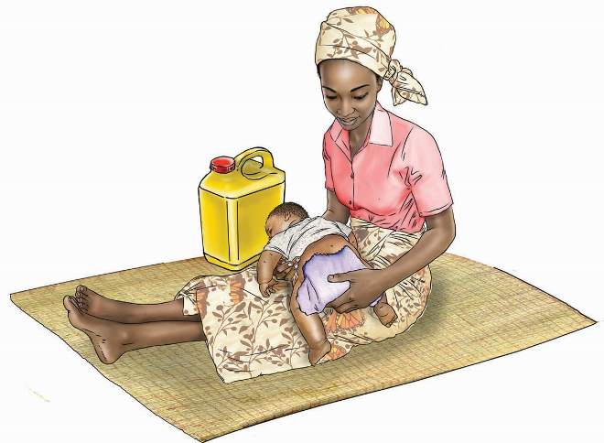
Your loving care helps your child grow and develop
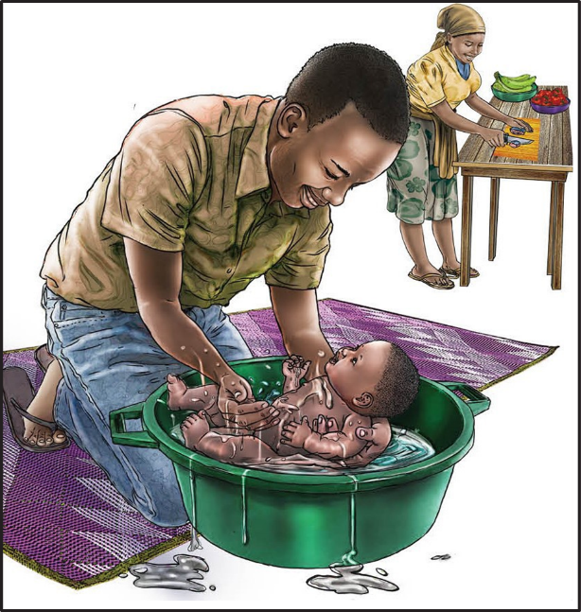
Card 1: Responsive Care

Card 1: Responsive Care

Steps 1-3: |  | After you have welcomed caregiver(s), assessed, and analyzed, you are ready to act!
Step 4: | Act
Introduce today’s topic using the Key Messages

  - You are already helping your child learn and develop every day when you talk, play, feed, and care for your child. These simple activities help your child’s brain to develop and make your child smart and clever.
  - Responsive care is about interacting with your child, showing love, and responding consistently to match the needs and interests of your child.
Praise, demonstrate, and practice with the Practical Tips

Learning your child’s cues
  - Your child tells you what he needs by using his sounds, facial expressions, and body movements. Observe your child. With practice, you will often be able to read your child’s cues and respond with what he needs.
  - Reading your child’s cues takes practice. Watch your child a lot and look for ways your child uses her eyes, mouth, and body to tell you what she needs. Crying is usually the last form of communication.
  - Create a daily routine for your child’s care, including times for meals
(starting at 6 months), bathing, and bedtime. Routines help your child feel secure because he knows and recognizes daily activities.
Responding when your child is upset
  - When your child is upset, think through possible solutions—she may be hungry, tired, soiled, uncomfortable, or sick.
  - Your child may just want your attention. Once you have calmed your child, think about the movements and sounds he was making. Over time, you will notice patterns in your child’s movements and sounds and the kinds of things he needs.
  - Gently rock, stroke, hold, or sing to your child. Provide skin-to-skin contact to stimulate and comfort your newborn baby.
  - Responsive care is fun and easy to do! Dads, moms, grandparents, and the whole family play an important role in making your child feel safe, loved, and secure.

Responding when your child wants to interact with you
  - Your child can see from the day she is born. Look into your child’s eyes often.
It will help her to connect with you, and she will learn to identify emotions in people.
  - Signs your baby wants your attention are wide-open eyes, looking toward
your face or toward someone who is talking, being alert, sucking on his fists
or objects, clasping his hands or feet together, and grasping on to your finger
or an object.
  - Respond to your child’s sounds and movements, such as reaching out, babbling, smiling, or making faces, by producing similar vocalizations, gestures, and talking to her.

Summarize and close
Step 5:
    - Summarize the session by asking the caregiver(s) to demonstrate or explain what they will go home and do with their child. Ask if the caregiver(s) see any barriers
and problem-solve together how to overcome those barriers.
    - If appropriate, agree on the next meeting date.

Teach your child to eat with love, patience, and good humor
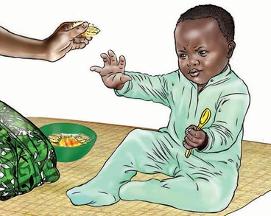
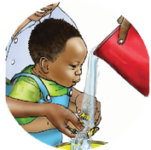
Card 2: Responsive Feeding

Card 2: Responsive Feeding

Steps 1-3: |  | After you have welcomed caregiver(s), assessed, and analyzed, you are ready to act!
Step 4: | Act
Introduce today’s topic using the Key Messages

    - Practice responsive care during feeding times with your child to show support and love. This means listening and watching for cues that your child is hungry or full and responding appropriately to those cues.
Praise, demonstrate, and practice with the Practical Tips

All children:
    - Minimize distractions during mealtimes. Face your child so you can focus on each other and on eating.
    - Pay attention to your child’s cues of hunger and fullness to be sure she is getting enough food but you are not overfeeding her. Never force a child to eat and never use food as a reward.
    - Be patient and give your child time to eat. If your child shows signs of fullness, slow down or pause. Try offering another bite after a minute or two. End the feeding if he again indicates he is full.
Responsive feeding helps make feeding a time of love and learning. It helps you and your child develop a strong bond and encourages good eating habits in your child as she grows.
Cues your baby is hungry  Wakes and tosses; sucks on fist (before 3 months); cries or fusses | Cues your baby is full  Closes mouth or lips shut; turns head away; decreases or stops sucking; spits out the nipple or falls asleep when full
Cues your child is hungry  Opens mouth while feeding to show wanting more; smiles, gazes at caregiver, or coos during feeding to show wanting more; moves head toward food or tries  to swipe food toward mouth; reaches or points for spoon or food | Cues your child is full  Slows down or stops eating; pushes food away; shakes head to say ‘‘no more’’

Birth up to 6 months:
  - Breast milk is all your baby needs for nutrition up to 6 months of age. Breastfeeding also stimulates loving feelings between mother and baby.
It helps your baby to feel safe and comforted.
  - During breastfeeding, a baby is learning how to control his appetite and soothe himself. He is determining how much milk he needs and how much
he wants to suck to comfort himself.
6 up to 9 months:
  - Slowly move the food in front of your baby’s eyes. When she begins to follow and reach for the food, respond by offering the food to eat.
9 up to 12 months:
  - Your baby may be interested in starting to use utensils or drinking water from a clean, open cup. Put some food on a spoon and let her try to feed herself. Give her a small cup with just a little bit of water to start and help her hold it. There will be spills, but encourage her. She will get better with practice!
12 up to 24 months:
  - You can start to provide small, cut-up bites of family foods for your child,
as his chewing skills are stronger now. Encourage him to feed himself—he
will get better and better at coordinating how to scoop up food and bring
it to his mouth.

Summarize and close
Step 5:
    - Summarize the session by asking the caregiver(s) to demonstrate or explain what they will go home and do with their child. Ask if the caregiver(s) see any barriers
and problem-solve together how to overcome those barriers.
    - If appropriate, agree on the next meeting date.

Listen and talk to your child all the time
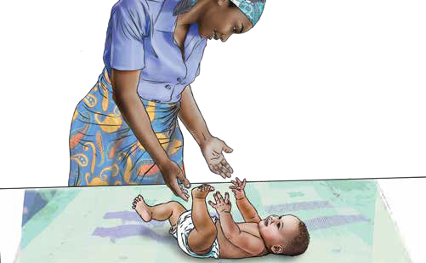
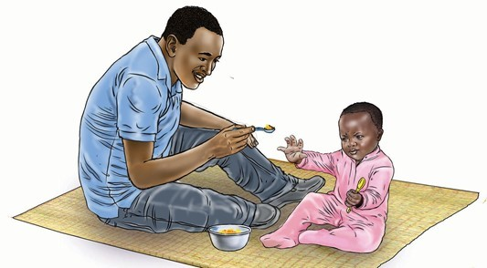
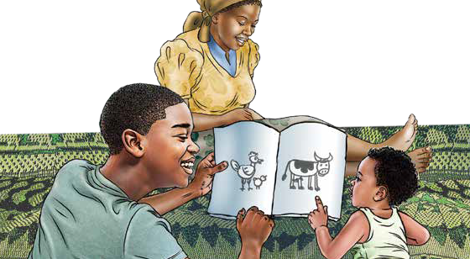
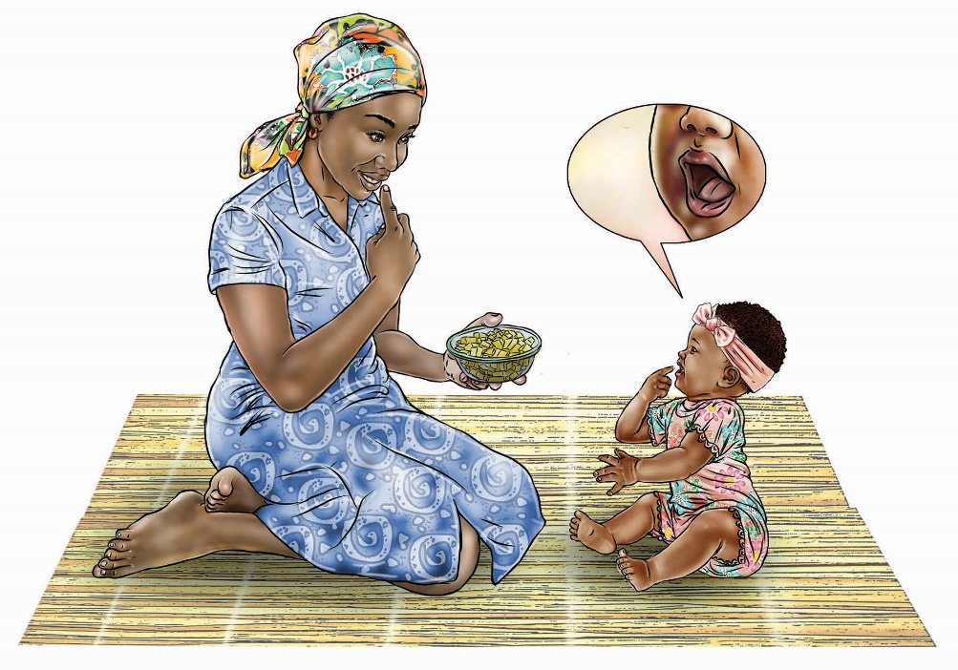
Card 3: Communication

Card 3: Communication

Steps 1-3: |  | After you have welcomed caregiver(s), assessed, and analyzed, you are ready to act!
Step 4: | Act
Introduce today’s topic using the Key Messages

    - Your child uses eye contact, cooing, facial expressions, and movement to tell you what she needs and wants from the day she is born. Follow her signals to understand her needs.
    - Babies begin to understand many words before they can speak. Talk and
sing to your child often so that he can hear words. He will learn to talk by listening to you talk.
    - Have a conversation with sounds, words, and gestures. When your child communicates with you using sounds or movements, respond to him and he will respond back. You are each taking turns in the conversation.
    - You can help your child learn new words by expanding on her language. If she says one word, such as “papa,” build her language by adding more words: “Papa loves you!”

Praise, demonstrate, and practice with the Practical Tips

Birth up to 6 months:
    - During or after breastfeeding, talk and sing to your baby. She is listening and will find comfort in your voice.
    - Imitate your baby’s sounds and gestures. He is communicating with you with his sounds and movements. When he coos, respond to him. Your baby needs to hear you talk.
6 up to 9 months:
    - Your baby can start to recognize common words. When you see your child is no longer hungry, ask her, “All done?” If she shows you that she is still hungry, say, “More?”
    - Respond to your baby’s sounds and interests. Call your baby’s name and notice his response.
9 up to 12 months:
    - Your baby will start to enjoy different soft foods now, such as soft fruits or cooked vegetables, and needs diverse, colorful foods to meet her nutritional needs. Use words to describe the food, and slowly she will understand new words. Name the different foods and parts of her body that she is using to eat, like her fingers and mouth.
  - Talk to your baby as you prepare his meal. Describe what is happening as you interact with him, such as saying, “Here is your bowl” or “Dad cooked you potatoes.” Ask him questions, “Do you want eggs?” Give him time to respond with gestures such as pointing or sounds before you provide a verbal answer.
12 up to 24 months:
  - As you feed your child, describe the colors and textures of her food. Encourage her to speak by asking her the name or the color of the food she is eating. Point and tell her the names of the foods after she has had a chance to try and answer you!
  - Sing with your child. Start a song and let him sing parts that he knows. Over time, he can sing more and more himself as he learns more words and you
can practice taking turns.
  - Children learn to love stories when they read together with their parents every day. Ask her to point to different people and animals in a book, magazine, or poster. Praise her for finding the animals and objects!

Summarize and close
Step 5:
    - Summarize the session by asking the caregiver(s) to demonstrate or explain what they will go home and do with their child. Ask if the caregiver(s) see any barriers
and problem-solve together how to overcome those barriers.
    - If appropriate, agree on the next meeting date.

Give your child daily opportunities to learn through play
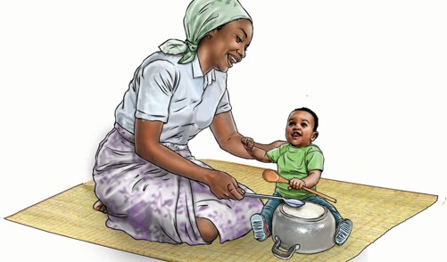
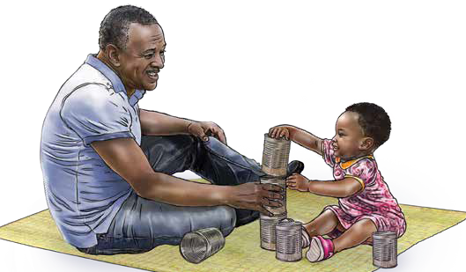
Card 4: Play

Card 4: Play

Steps 1-3: |  | After you have welcomed caregiver(s), assessed, and analyzed, you are ready to act!
Step 4: | Act
Introduce today’s topic using the Key Messages

    - Children learn by playing, observing, copying, and trying new things starting from the moment they are born. Your child enjoys and learns through playing with you! All your child needs is you.
    - Give your child opportunities to explore the world around him through play. He will enjoy playing with his fingers and toes, your face, and household objects. Follow his lead, encouraging play with safe objects that interest him. Observe his body language and sounds, and do not force him to play with something when he is not interested.
Praise, demonstrate, and practice with the Practical Tips
Birth up to 6 months:
    - Slowly move colorful objects for your baby to see and reach for. Watch his eyes move side to side as he follows the object.
    - Place your baby on her tummy with a colorful object out in front of her. Watch her reach for it and praise her when she picks it up! She learns by putting objects in her mouth so make sure the object is clean, not sharp, and not too small that she could swallow it.
6 up to 9 months:
    - As you introduce new foods for your baby, he is learning new textures and tastes. Encourage him when he tries new foods! Having diverse and colorful foods is important.
    - Give your baby clean, safe household objects to pick up, touch, feel, bang, and explore. Examples of simple toys to play with include small containers or a pot with a spoon.
    - Draw or make simple picture books to develop your baby’s curiosity and help her learn new things.
  - Give your child challenging but achievable tasks. Guide her actions and build on what she can do to make the task slightly more difficult.

9 up to 12 months:
  - During mealtimes, give your baby small finger foods and encourage him to try new, healthy foods. He is starting to learn how to pick up things with his fingers and chew. He will often make a mess and that is okay! He is learning to feed himself and exploring different types of foods!
  - Play games like “peekaboo” with your baby. While she is looking at you, cover your face with hands or fabric. Say, “Where is Mommy?” Open hands and say, “Boo! Here I am!” Laugh with her as she sees you! She is starting to learn that you do not disappear when she does not see you.
12 up to 24 months:
  - Play with your child and encourage him to try harder tasks. Encourage him to stack objects, knock them over, and start again. Give him more objects to stack. Help him if he gets stuck!
  - Encourage your child’s imagination using sock puppets. Make up a story using the puppets.

Summarize and close
Step 5:
    - Summarize the session by asking the caregiver(s) to demonstrate or explain what they will go home and do with their child. Ask if the caregiver(s) see any barriers
and problem-solve together how to overcome those barriers.
    - If appropriate, agree on the next meeting date.

Seek help if you are concerned about your
child’s development
Health Facility
Card 5: Monitoring Child Development

Card 5: Monitoring Child Development

Steps 1-3: |  | After you have welcomed caregiver(s), assessed, and analyzed, you are ready to act!
Step 4: | Act
Introduce today’s topic using the Key Messages

    - Children learn at different paces. Some children learn quickly, and some children need more time. But remember, all children can learn! Children’s skills build upon one another. For example, a child must learn to sit before he can stand.
    - Some children are born with or develop conditions that can affect their abilities. Children may develop differently in how they move, see, hear, learn, think, or interact with others.
    - Many conditions contribute to children developing differently. You may hear many things about disabilities in your community, but it is important to know that disabilities are not the fault of the mom or dad, and they are not a curse. All children can learn, and some children may need extra support.
    - All children should have their growth, development, hearing, and vision monitored to identify any concerns early. If you are concerned about your child’s development, seek support from a health care provider.

Praise, demonstrate, and practice with the Practical Tips
Concerns about development |  | Concerns about feeding

      - IF CONCERNS, SAY: All children develop at different paces. If there are any difficulties, children benefit from early identification and support. You should visit a health facility to discuss your concerns further with a skilled provider.
      - WARNING SIGNS FOR REFERRALS: If your child ever regresses, meaning he stops being able to perform skills that he used to do such as talking or walking, this can be a sign of a serious problem. You must seek care immediately.
Concerns about hearing or vision
      - IF CONCERNS, SAY: You should visit a health facility to discuss your concerns further with a skilled provider and have them check your child’s hearing and vision.
      - WARNING SIGNS FOR REFERRALS: If your child does not respond
to noise or does not use her eyes to follow your face or objects by age 3 months, seek care at your health facility.
  - IF CONCERNS, SAY: I would be happy to talk with you about some strategies to help your child to feed. If the problems persist, you should visit a health facility. (See: “Special Circumstances Counseling Card 7.”)
  - WARNING SIGNS FOR REFERRALS: Seek care immediately if your child is losing weight, frequently coughs or tears while feeding, has rigid muscles or jaw clenching that prevent feeding, vomits frequently, or sweats excessively or tires quickly when feeding.
No concerns
  - Praise the caregiver for all of their efforts to help their child grow and develop! Encourage the caregiver to keep practicing responsive care and age-appropriate feeding practices. See IYCF cards on breastfeeding and complementary feeding topics and the Communication and Play cards from this RCEL Addendum for more specific ideas.

Summarize and close
Step 5:
    - Summarize the session by asking the caregiver(s) to demonstrate or explain what they will go home and do with their child. Ask if the caregiver(s) see any barriers and problem-solve together how to overcome those barriers.
    - If appropriate, agree on the next meeting date.

Take care of yourself in order to care for your child
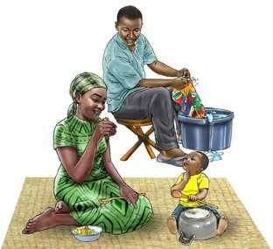
Card 6: Caring for the Caregiver

Card 6: Caring for the Caregiver

Steps 1-3: |  | After you have welcomed caregiver(s), assessed, and analyzed, you are ready to act!
Step 4: | Act
Introduce today’s topic using the Key Messages

    - Your child loves spending time with you. He is learning by observing, imitating, listening, and interacting with you. Parenting is rewarding and fun, but it is not always easy.
    - Feeling big emotions during caregiving is normal because it can be very stressful. Feeling these emotions is not something to feel guilty or ashamed about. All caregivers need emotional support and help from their partners, families, friends, and community.
    - Creating routines is helpful for you and your child. Think of ways to include activities you enjoy in your routine. Consider singing, sewing, exercise, dancing, drawing, or any activity that calms you and helps you to take care of yourself.
Praise, demonstrate, and practice with the Practical Tips

Birth up to 6 months:
    - Your baby is feeding on demand all day and all night and depending on mom and dad for everything.
    - Ask your partner, other family members, and friends for help. It will benefit your baby and you and give you time to take care of yourself, such as time to visit with a friend, get some sleep or do any healthy activity that helps you relax. This can help prevent you from feeling exhausted and overwhelmed.
6 up to 12 months:
    - Your baby is starting to feed on solid foods, sleeps less, and is moving around! He might develop some fears of people he does not know and want to be with you all the time.
    - It is okay to feel frustrated because you cannot get your baby to calm down or she is not behaving how you would like. Take a moment and take several
  - Talk with your spouse, friends, or family members. Share your experiences parenting with a confidant. Share both what is going well and any challenges you are having.
  - Whenever you feel exhausted and overwhelmed, it is good to reach out for help from your partner, family, or friends. If these feelings do not go away, seek care from your health facility. Depression and anxiety are common challenges, especially in the postpartum period, and require treatment.

slow, deep breaths in and out. Focus on your breathing to calm yourself before going back to try to calm your baby. Do not hesitate
to ask a family member or friend to help if you need a little rest.
12 up to 24 months:
  - Your child is developing her emotions, and she will soon start to do more things for herself like getting dressed and toileting. She will get frustrated when she tries but cannot do things herself. She may appear stubborn or get upset.
  - Recognize that this is normal and do not get angry. Step away if you need
to, and do not be hard on yourself. Ask your partner or a confidant to look after your child while you step away. Even 10 minutes away from a stressful situation can help you feel more calm and able to respond appropriately.

Summarize and close
Step 5:
    - Summarize the session by asking the caregiver(s) to demonstrate or explain what they will go home and do. Ask if the caregiver(s) see any barriers and problem-solve together how to overcome those barriers.
    - If appropriate, agree on the next meeting date.

Difficulty controlling
head or body
Persistent difficulty
chewing or swallowing
Difficulty self-feeding
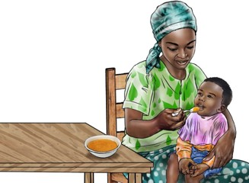
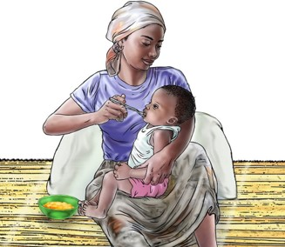
Special Circumstances Card 7: Feeding Difficulties

Card 7: Feeding Difficulties

Steps 1-3: |  | After you have welcomed caregiver(s), assessed, and analyzed, you are ready to act!
Step 4: | Act
Introduce today’s topic using the Key Messages

    - Sometimes children have difficulties feeding, and they may require additional support to be able to feed well. It is important to consult a health care provider if you have any concerns about your child’s feeding.
    - Children with feeding difficulties are at increased risk of becoming malnourished. Regular growth monitoring and feeding a variety of foods at each meal is important for all children. Food such as oil, ghee, and butter provide extra energy. Other high energy foods include seeds,
Praise, demonstrate, and practice with the Practical Tips for complementary feeding starting at 6 months
Difficulty controlling head or body:
    - A stable, upright position with support for eating and drinking is one of
the most important factors for safe feeding. Make sure your child’s whole body is supported well, so that she can focus on eating.
    - If your child is floppy, provide support to his back and head using your body or a chair. Always keep his head upright while feeding to prevent choking or having food go down his airway.
Persistent difficulty chewing or swallowing:
    - Difficulty chewing and swallowing can cause choking and can lead to illness. Consult with a health care provider and ask for specific feeding strategies for your child.
    - Consider pureeing foods by passing soft foods through a sieve. It is easier
for children to learn to control foods in their mouth and swallow if they
are only one texture.
    - Water and other liquids are easy for children to choke on if they have problems swallowing. Never pour liquids into your child’s mouth. Consider thicker liquids like soft porridge or yogurt.
Difficulty self-feeding:
    - Spoons and forks with thicker handles are easier for children to hold. Attach
  - Seek immediate care at a facility if your child is losing weight, or displays warning signs like frequent coughing or tearing while feeding, jaw tightening that prevents feeding, fast breathing or breathing becoming wet-sounding, excessive sweating or tiring quickly when feeding, or vomiting after feeding.

a rubber tube or piece of wood to the spoon handle to make it thicker.
  - Plates with steep sides may make it easier for some children to scoop up food themselves.
Picky eating:
  - Wait until your child is hungry to give her healthy foods she has not liked in the past. She may be more willing to try them when she is hungry.
  - Let him feed himself. This will help him feel like he is in control of what he is eating.
  - Do not use food as a reward or as a punishment. Your child will eat when
she is hungry.
Poor appetite:
  - Provide more frequent, smaller meals throughout the day.
  - Avoid juices or sugary drinks. Provide only breast milk and water instead.
  - Avoid distractions during mealtimes, and encourage routines of the family eating together to make mealtime fun.
  - A child is getting enough to eat if they are growing well.
  - Consult with a health care provider if you are concerned or if your child’s poor appetite lasts for several days.

Note: If a child is having difficulties latching to the breast, review IYCF cards for guidance on different positions, breast milk expression, and safe cup feeding. If the child is
sick with common illnesses such as fever or diarrhea, refer to the IYCF card on feeding a sick baby under 6 months of age or a sick child older than 6 months of age.
Step 5: | Summarize and close
    - Make sure there is a clear plan to visit the health facility to address the feeding issues. Summarize the session by asking the caregiver(s) to demonstrate or explain what they will go home and do with their child. Ask if the caregiver(s) see any barriers and problem-solve together how to overcome them. Agree on next meeting date.

Tips for Supporting Children with Disabilities to Engage in Play and Learning

Modify the skill level
Consider sharing Practical Tips that the child can do, or are slightly challenging for the child, rather than focusing  on the tips that match the child’s age.  - Make an activity simpler by breaking it into multiple steps, such as providing only two objects to stack rather than many and adding more as the child progresses.  - Provide materials that are easier for a child to use: a container with a handle the child can grip rather than a jar with no handles.  - Consider adaptive devices to help a child: add a thicker handle to a spoon or utensil to make self-feeding easier or provide a supportive chair to help the child to sit. |  | 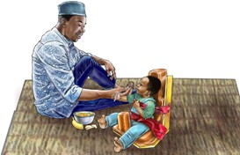
Add a sensory component (touch, sound, sight, smell)
Adding more touch, sound, smell, or a visual component will stimulate the child’s senses, particularly if the child
has an impairment that affects their senses, such as difficulty seeing or hearing.
- Add a touch component to a story: if the story is about bath time, splash a little water on the child’s hand.
- Add a smell to a shaker toy: add strips of lemongrass or spices in a container with bottle caps.
- Provide different textures of playthings: things that are smooth (like plastic), soft (like different fabrics), or rough (like stiff leaves glued to cardboard). Ensure that the objects are safe: clean, not sharp, and larger than your child’s palm to prevent choking.

Support the child in exploring
Play should be led by the child, with the caregiver providing support only as needed by the child.
Be patient and let the child take time to engage with an object or an activity. Remove objects that get in the way of playing.
- Provide some extra support during tummy time (like rolled-up fabric) under the child’s chest to prop the child’s torso up or place the child on your chest and recline back.
- Guide the child’s hand alongside yours to explore an object or position the child in a way that helps her be able to look around and engage in play. Make sure the child’s arms and legs are not restricted.
- Look for the subtle cues the child may use to communicate, such as using eye movements to look at something they want.

Job Aid: Disability Inclusion

USAID ADVANCING NUTRITION
Implemented by:
JSI Research & Training Institute, Inc. 2733 Crystal Drive
4th Floor
Arlington, VA 22202

Phone: 703–528–7474
Email: info@advancingnutrition.org Web: advancingnutrition.org

September 2023

USAID Advancing Nutrition is the Agency’s flagship multi-sectoral nutrition project, addressing the root causes of malnutrition to save lives and enhance long-term health and development.

These cards are made possible by the generous support of the American people through the United States Agency for International Development (USAID). The contents are the responsibility of JSI Research & Training Institute, Inc. (JSI), and do not necessarily reflect the views of USAID or the United States government.

