Responsive Care and Early Learning Addendum Training Package
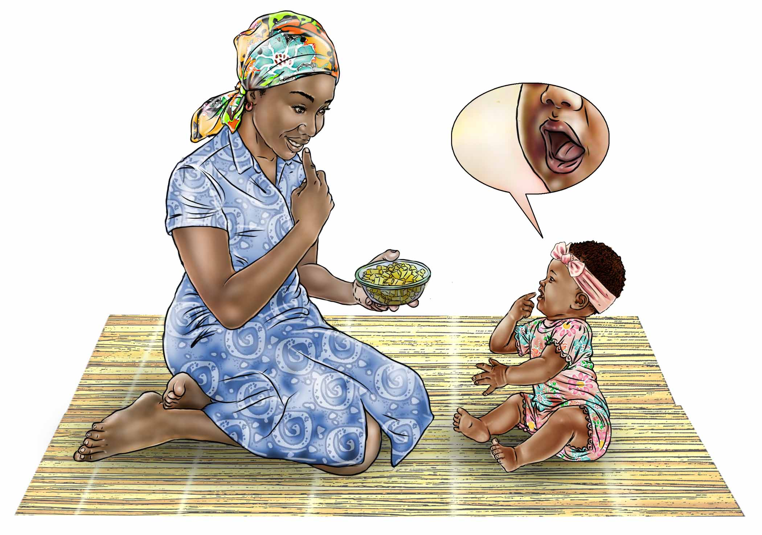
Training Aid
About USAID Advancing Nutrition
USAID Advancing Nutrition is the Agency’s flagship multi-sectoral nutrition project, led by JSI Research & Training Institute, Inc. (JSI), and a diverse group of experienced partners. Launched in September 2018, USAID Advancing Nutrition implements nutrition interventions across sectors and disciplines for USAID and its partners. The project’s multi-sectoral approach draws together global nutrition experience to design, implement, and evaluate programs that address the root causes of malnutrition. Committed to using a systems approach, USAID Advancing Nutrition strives to sustain positive outcomes by building local capacity, supporting behavior change, and strengthening the enabling environment to save lives, improve health, build resilience, increase economic productivity, and advance development.
Disclaimer
This document is made possible by the generous support of the American people through the United States Agency for International Development (USAID). The contents are the responsibility of JSI Research & Training Institute, Inc. (JSI), and do not necessarily reflect the views of USAID or the United States Government.
Recommended Citation
USAID Advancing Nutrition. 2023. Responsive Care and Early Learning Addendum Training Package: Training Aid. Arlington, VA: USAID Advancing Nutrition.
Image Credit: Víctor Nolasco for JSI
USAID Advancing Nutrition
JSI Research & Training Institute, Inc.
2733 Crystal Drive
4th Floor
Arlington, VA 22202
Phone: 703–528–7474
Email: info@advancingnutrition.org
Web: advancingnutrition.org

Contents
Session 2, Learning Objective1 1
Training Aid 2.1: Illustration of a Healthy Baby 1
Training Aid 2.2: Five Components of the Nurturing Care Framework 3
Session 2, Learning Objective 2 9
Training Aid 2.3: Experience Cards (Child A) 9
Training Aid 2.4: Experience Cards (Child B) 14
Training Aid 2.5: Colorful Smiley Faces and White Faces with Frowns 19
Session 2, Learning Objective 3 30
Training Aid 2.6: Four Domains of Development 30
Session 5, Learning Objective 1 35
Training Aid 5.1: Responsive Care Stories (each page is one story) 35
Session 6, Learning Objective 1 41
Training Aid 6.1: Communication and Play Practical Tips for Caregivers 41
Session 7, Learning Objective 1 49
Training Aid 7.1: Happy Face, Neutral Face, Sad Face 49
Session 9, Learning Objective 1 50
Training Aid 9.1: Developmental Milestone Cards 51
Session 11, Learning Objective 2 67
Training Aid 11.1: Problem and Solution Cards for Children with Feeding Difficulties 67

Session 2, Learning Objective1

Training Aid 2.1: Illustration of a Healthy Baby

Training Aid 2.2: Five Components of the Nurturing Care Framework
Good health | Adequate nutrition | Opportunities  for early learning
Safety and security | Responsive caregiving
Source: WHO (World Health Organization), UNICEF (United Nations Children’s Fund), and World Bank Group. 2018. Nurturing Care Framework for Early Childhood Development: A Framework for Helping Children Survive and Thrive to Transform Health and Human Potential. Geneva: WHO. https://apps.who.int/iris/bitstream/handle/10665/272603/9789241514064-eng.pdf

Good Health

Adequate Nutrition

Opportunities for Early Learning
Safety and Security

Responsive Caregiving

Session 2, Learning Objective 2

Training Aid 2.3: Experience Cards (Child A)
Positive Experiences
Engaging in play with caregivers | Hygiene and quality time  with dad  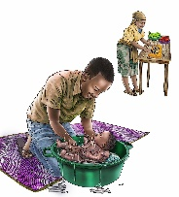 | Responding to a child’s nonverbal communication  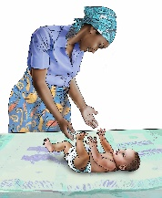
Exclusive breastfeeding during the first 6 months | Growth monitoring  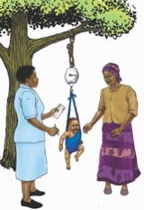
Negative Experiences
Witness domestic violence
Lack of screening services resulted in delayed detection and intervention for hearing loss

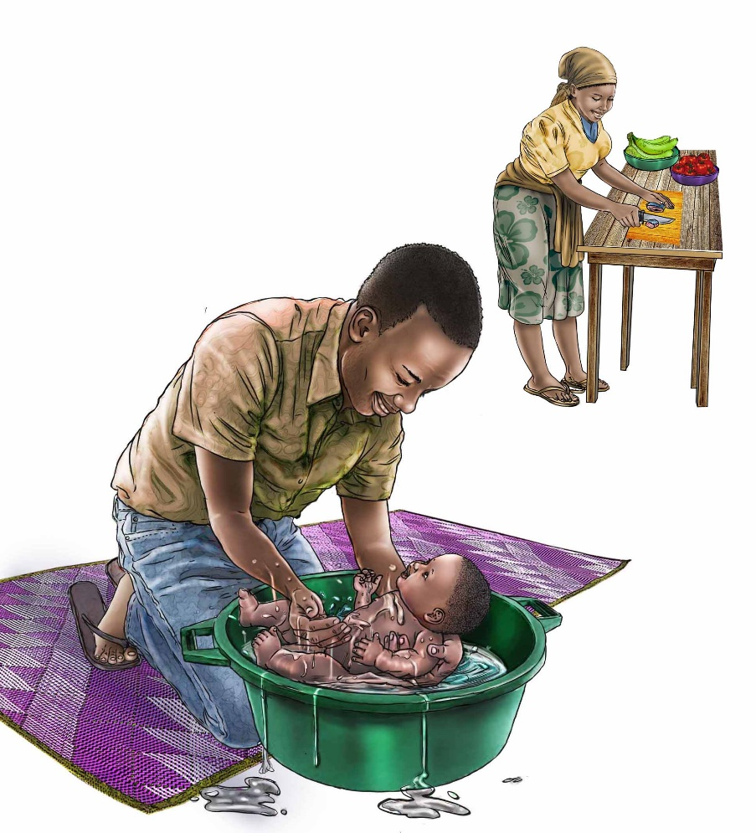
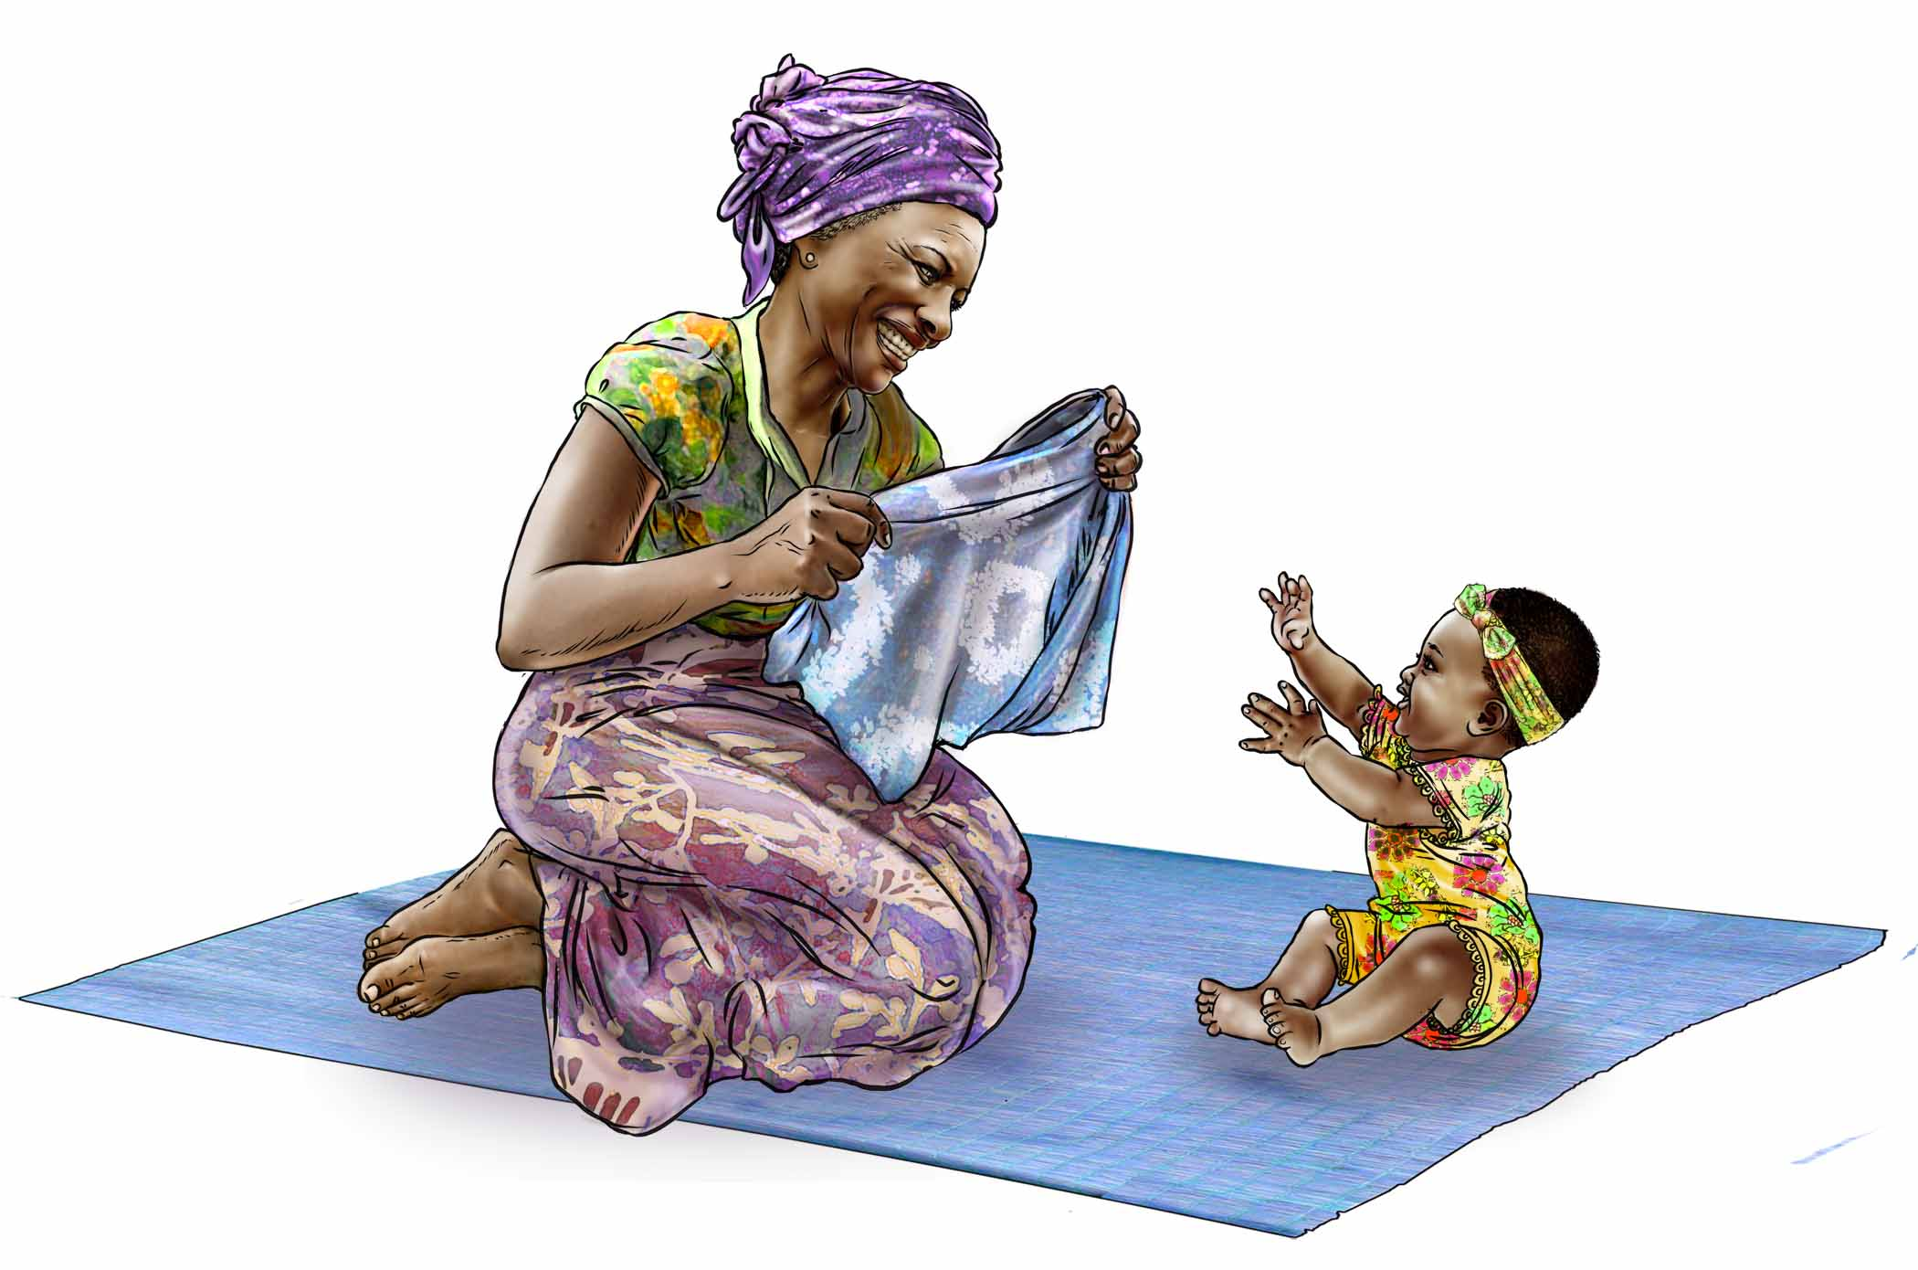
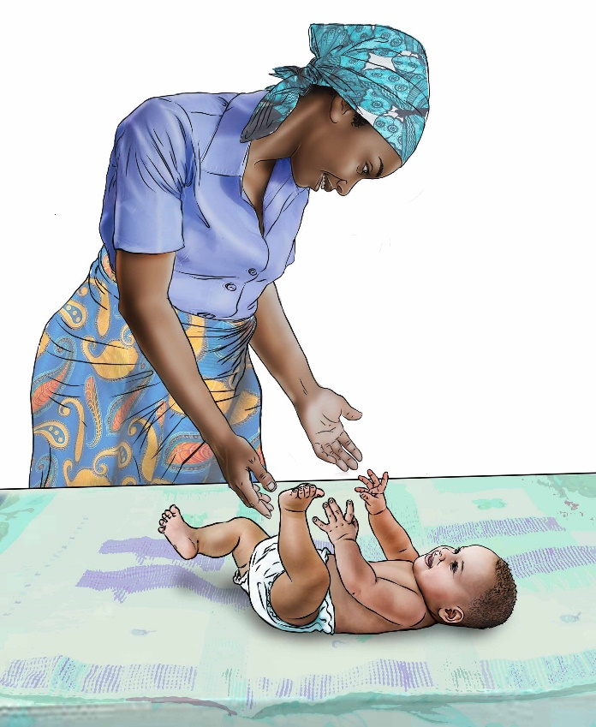
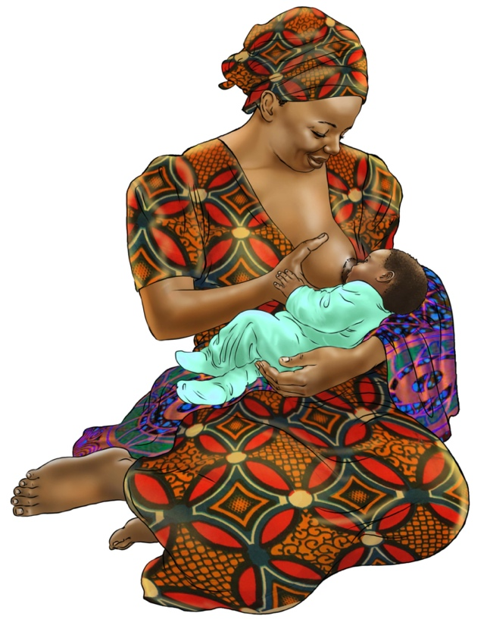
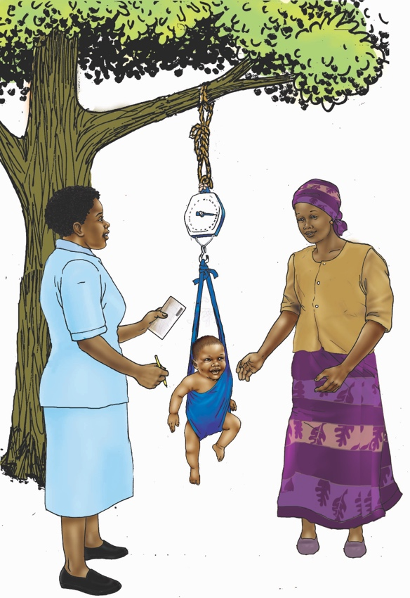
Witness domestic violence
Lack of screening services resulted in delayed detection and intervention for hearing loss

Training Aid 2.4: Experience Cards (Child B)
Positive Experiences
Meeting a child’s basic needs  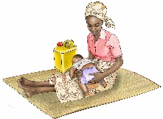 | Complementary feeding from 6–24 months  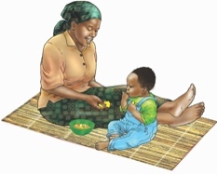
Negative Experiences
Caregiver depression
Food insecurity
Born premature
Malnutrition
Repeated physical punishment

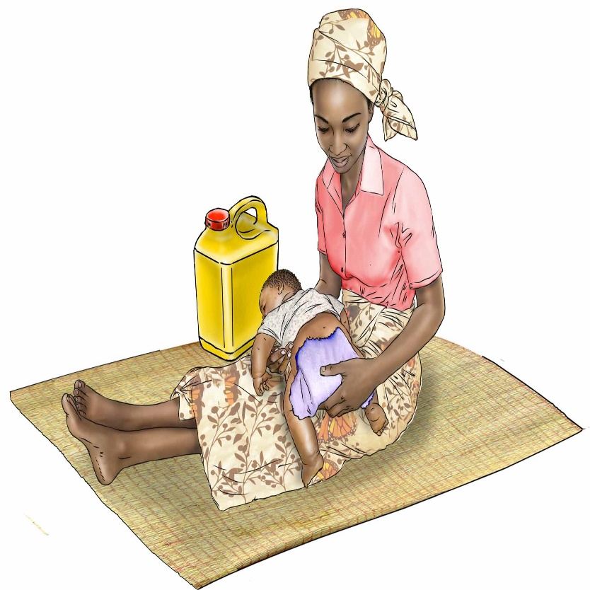
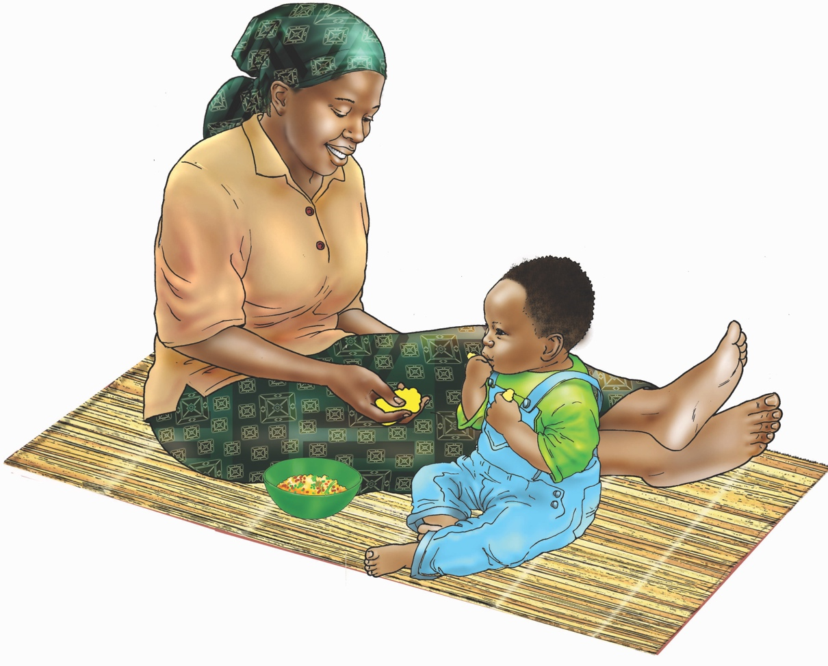
Food
insecurity
Born premature
Caregiver depression
Malnutrition
Repeated physical punishment

Training Aid 2.5: Colorful Smiley Faces and White Faces with Frowns
10 colorful smiley faces | 10 white faces with frowns

Session 2, Learning Objective 3

Training Aid 2.6: Four Domains of Development
Physical | 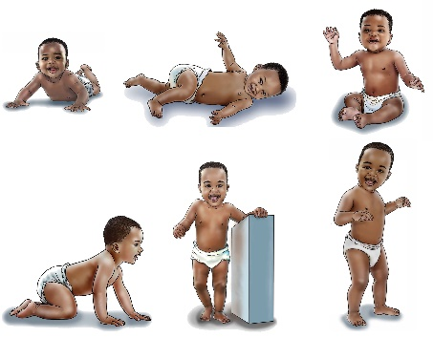
Cognitive | 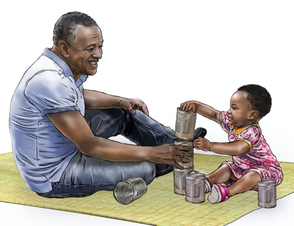
Language | 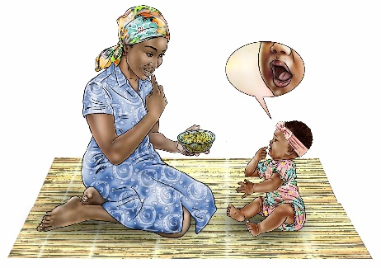
Social/emotional | 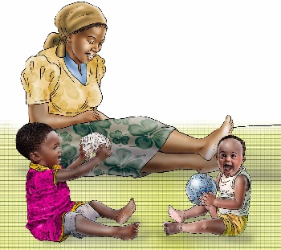

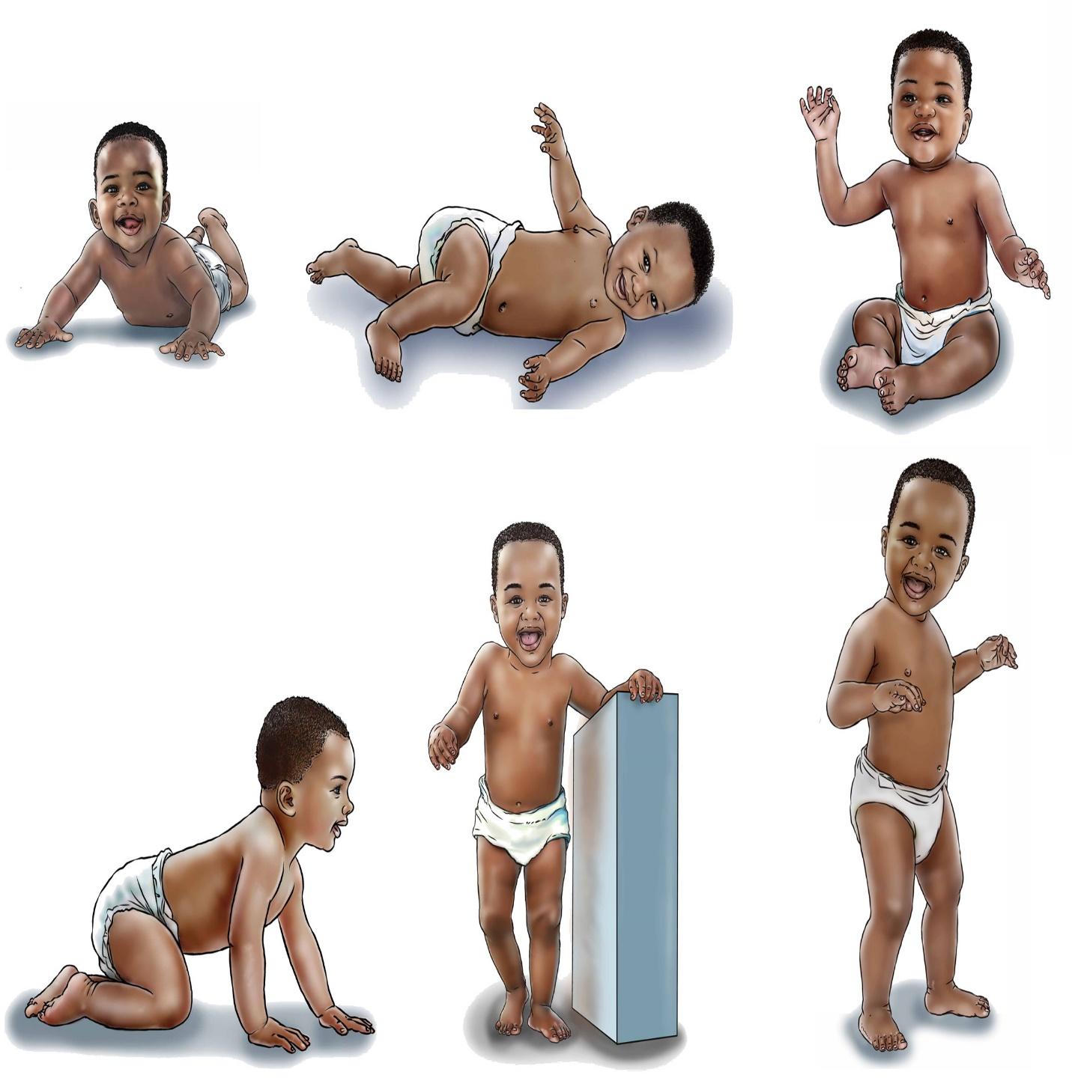
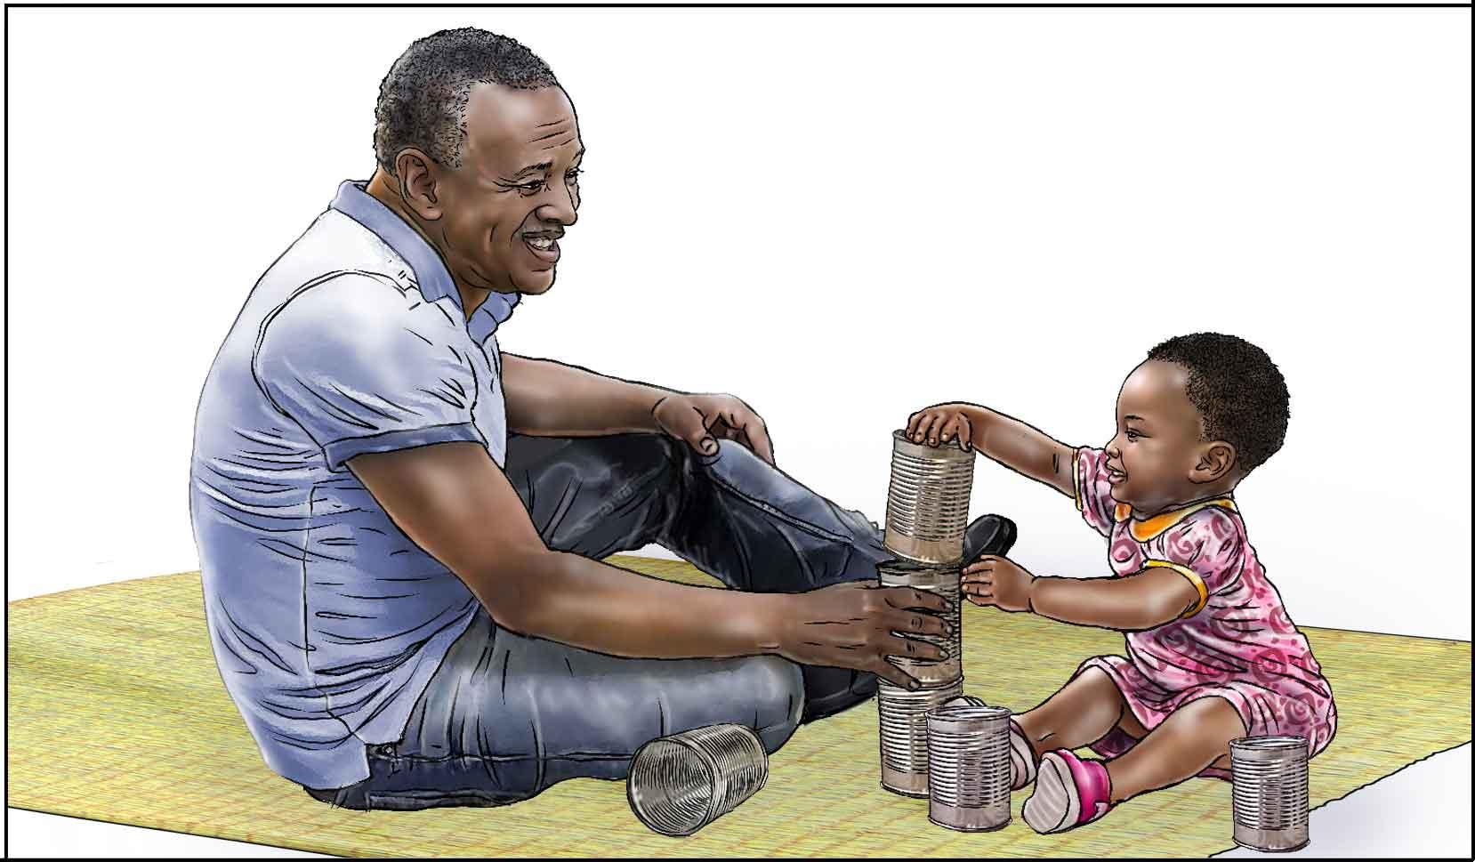
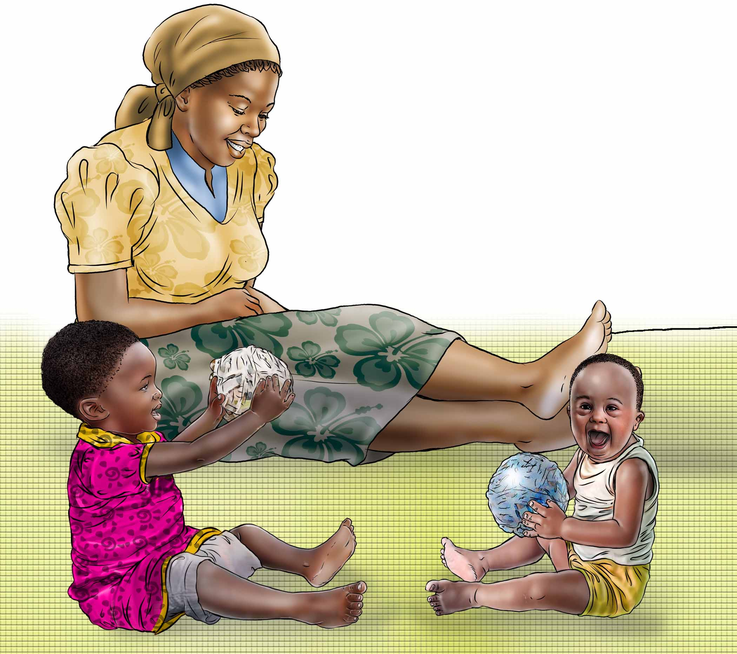

Session 5, Learning Objective 1

Training Aid 5.1: Responsive Care Stories (each page is one story)
Story 1  Playing and Stacking Blocks  (22 months of age) | 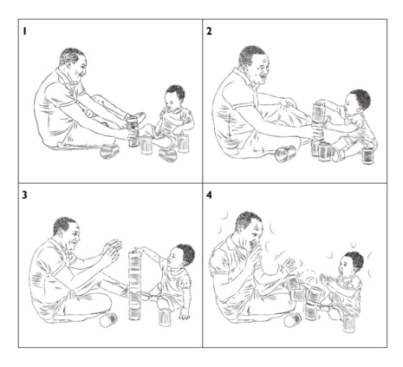
Story 2  Responsive Breastfeeding  (<1 month of age/newborn) | 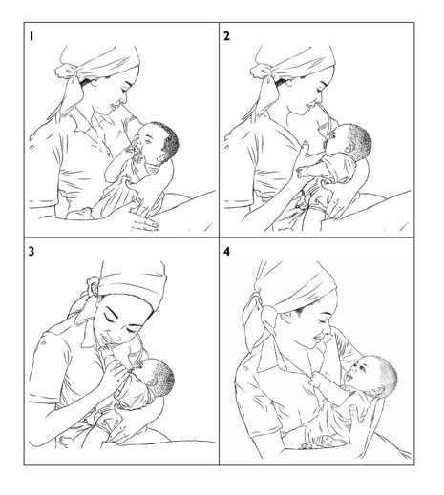
Story 3  Early Communication  (20 months of age) | 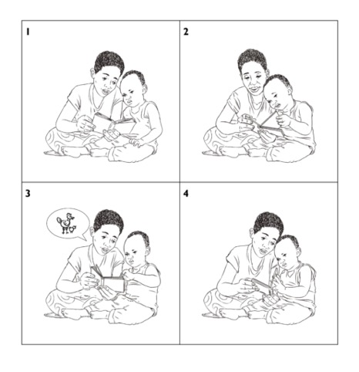
Story 4  Satiety Cues  (9 months of age) | 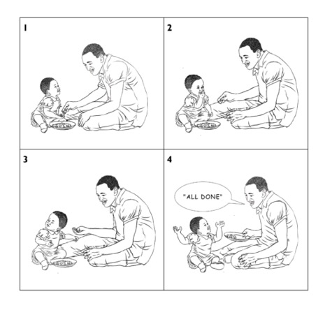
Story 5  Tired Cues  (1 month of age) | 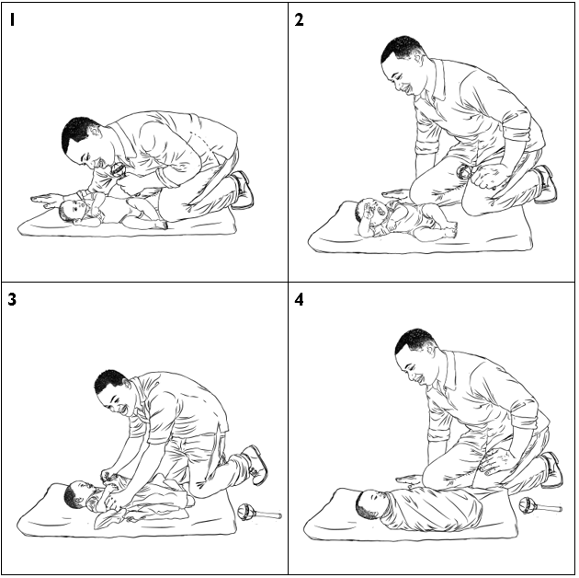

Story 1: Playing and Stacking Blocks (22 months of age)
Instructions: Review all four images in order from 1 to 4 to understand what is happening in this story. Then discuss the following questions about the story:
- What do you notice about the caregiver-child interaction?
- What do you notice about the caregiver and child’s facial expressions?
- What cues is the child giving?
- Does the caregiver respond to the cues? If not, what could the caregiver have done?
- What do you notice about the position of the caregiver?
- How does the caregiver feel in this story?
- How does the child feel in this story?
1  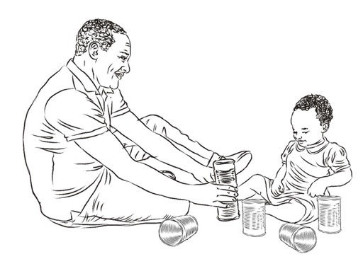 | 2  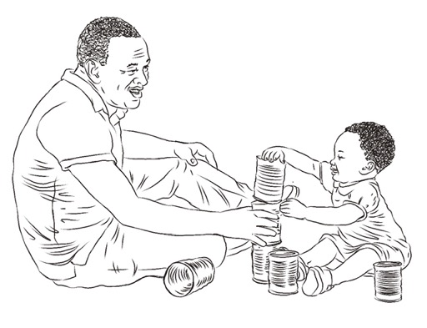
3  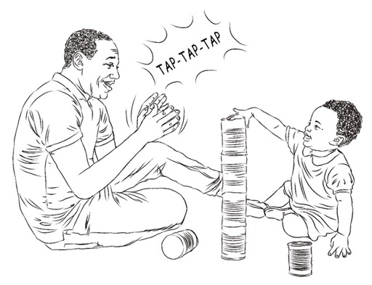 | 4  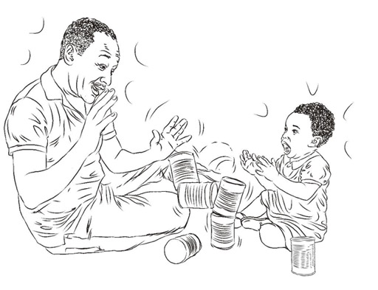
Story 2: Responsive Breastfeeding (< 1 month of age/newborn)
Instructions: Review all four images in order from 1 to 4 to understand what is happening in this story. Then discuss the following questions about the story:
- What do you notice about the caregiver-child interaction?
- What do you notice about the caregiver and child’s facial expressions?
- What cues is the child giving?
- Does the caregiver respond to the cues? If not, what could the caregiver have done?
- What do you notice about the position of the caregiver?
- How does the caregiver feel in this story?
- How does the child feel in this story?
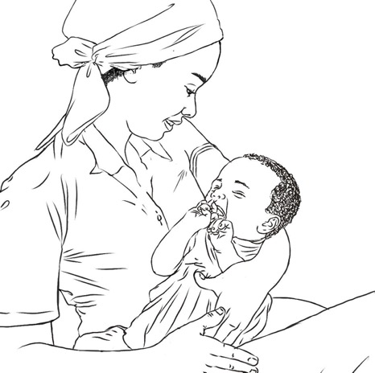 | 2  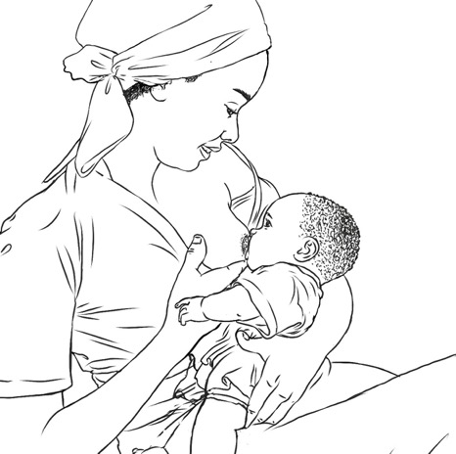
3  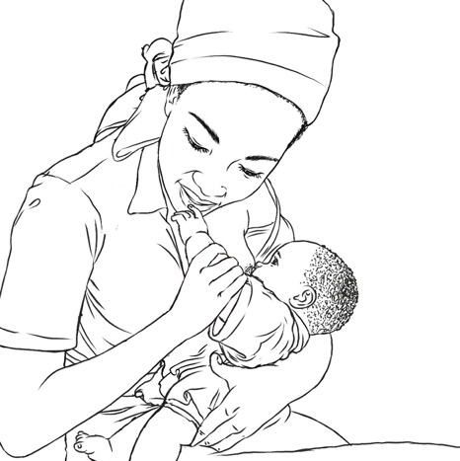 | 4  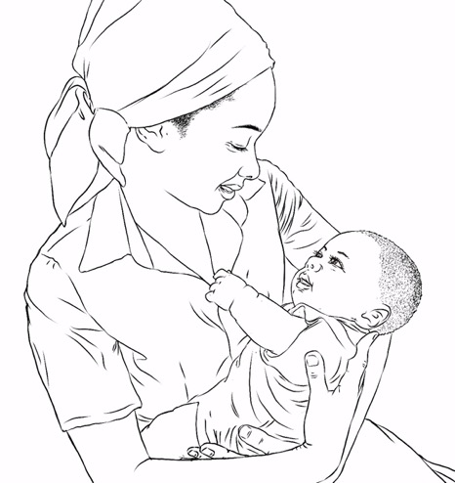
Story 3: Early Communication (20 months of age)
Instructions: Review all four images in order from 1 to 4 to understand what is happening in this story. Then discuss the following questions about the story:
- What do you notice about the caregiver-child interaction?
- What do you notice about the caregiver and child’s facial expressions?
- What cues is the child giving?
- Does the caregiver respond to the cues? If not, what could the caregiver have done?
- What do you notice about the position of the caregiver?
- How does the caregiver feel in this story?
- How does the child feel in this story?
1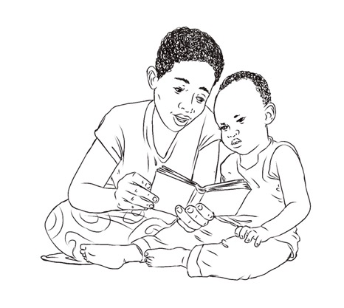 | 2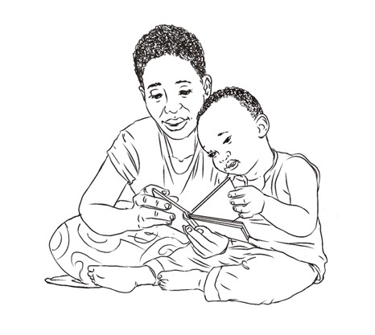
3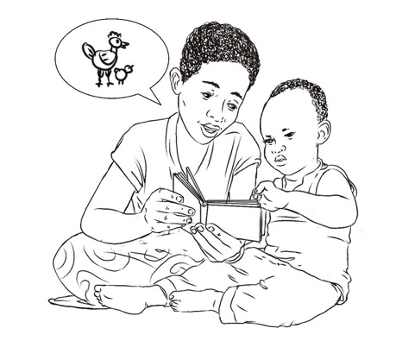 | 4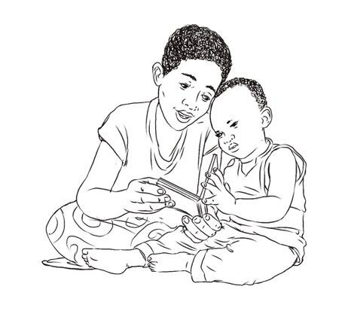

Story 4: Satiety Cues (9 months of age)
Instructions: Review all four images in order from 1 to 4 to understand what is happening in this story. Then discuss the following questions about the story:
- What do you notice about the caregiver-child interaction?
- What do you notice about the caregiver and child’s facial expressions?
- What cues is the child giving?
- Does the caregiver respond to the cues? If not, what could the caregiver have done?
- What do you notice about the position of the caregiver?
- How does the caregiver feel in this story?
- How does the child feel in this story?
1  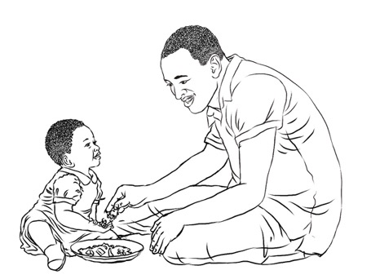 | 2  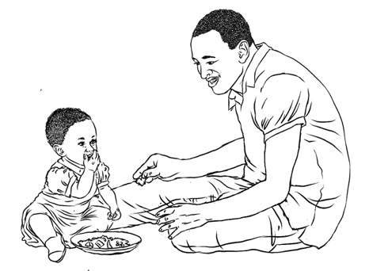
3  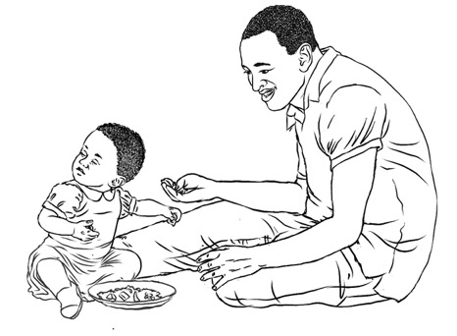 | 4  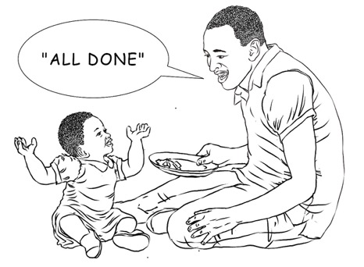

Story 5: Tired Cues (1 month of age)
Instructions: Review all four images in order from 1 to 4 to understand what is happening in this story. Then discuss the following questions about the story:
- What do you notice about the caregiver-child interaction?
- What do you notice about the caregiver and child’s facial expressions?
- What cues is the child giving?
- Does the caregiver respond to the cues? If not, what could the caregiver have done?
- What do you notice about the position of the caregiver?
- How does the caregiver feel in this story?
- How does the child feel in this story?
1  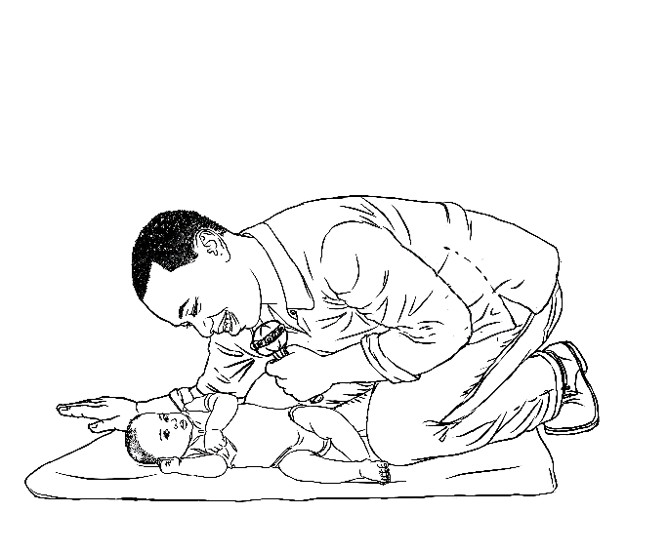 | 2  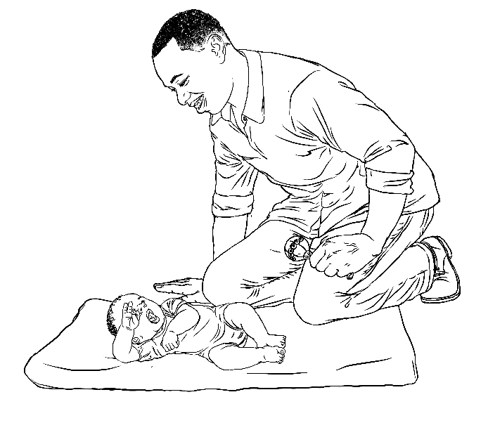
3  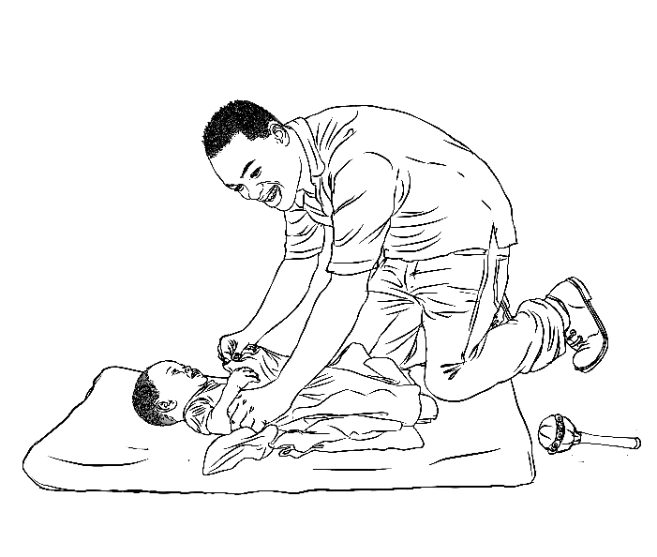 | 4  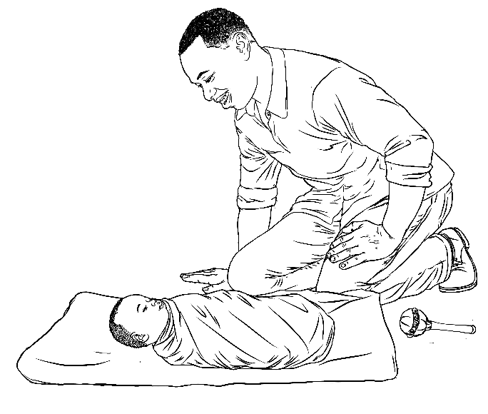

Session 6, Learning Objective 1

Training Aid 6.1: Communication and Play Practical Tips for Caregivers
During or after breastfeeding, talk and sing to your baby.
She is listening and will find comfort in your voice.
Imitate your baby’s sounds and gestures. He is communicating with you with his sounds and movements. When he coos, respond to him. Your baby needs to hear you talk. He will learn to talk by listening to others around him.
Your baby can start to recognize common words.
When you see your child is no longer hungry, ask her,
“All done?” If she shows you that she is still hungry, say, “More?”
Respond to your baby’s sounds and interests.
Call your baby’s name and notice his response.
Your baby will start to enjoy different soft foods now, such as soft fruits or cooked vegetables, and needs diverse, colorful foods to meet her nutritional needs. Use words to describe the food and slowly she will understand new words. Name the different foods and parts of her body that she is using to eat, like her fingers and mouth.
Talk to your baby as you prepare his meal. Describe what is happening as you interact with him, such as “Here is your bowl” or “Dad cooked you potatoes.” Ask him questions, “Do you want eggs?” Give him time to respond with gestures such as pointing or sounds before you provide a verbal answer.
As you feed your child, describe the colors and textures of her food.
Encourage her to speak by asking her the name or the color of the food she is eating. Point and tell her the names of the foods after she has had a chance to try and answer you!
Sing with your child. Start a song and let him sing parts that he knows.
Over time, he can sing more and more himself as he learns more words, and you can practice taking turns.
Children learn to love stories when they read together with their parents every day. Ask her to point to different people and animals in a book, magazine, or poster. Praise her for finding the animals and objects!
Slowly move colorful objects for your baby to see and reach for.
Watch his eyes move side to side as he follows the object.
Place your baby on her tummy with a colorful object out in front of her. Watch her reach for it and praise her when she picks it up! She learns by putting objects in her mouth so make sure the object is clean, not sharp, and not too small that she could swallow it.
As you introduce new foods for your baby, he is learning new textures and tastes. Encourage him when he tries new foods! Having diverse and colorful foods is important.
Give your baby clean, safe household objects to pick up, touch, feel, bang, and explore. Examples of simple toys to play with include small containers or a pot with a spoon.
Draw or make simple picture books to develop your baby’s curiosity and help her learn new things.
During mealtimes, give your baby small finger foods and encourage him to try new, healthy foods. He is starting to learn how to pick up things with his fingers and chew. He will often make a mess and that is okay! He is learning to feed himself and exploring different types of foods!
Play games like “peekaboo” with your baby. While she is looking at you, cover your face with hands or fabric. Say, “Where is Mommy?” Open hands and say, “Boo! Here I am!” Laugh with her as she sees you! She is starting to learn that you do not disappear when she does not see you.
Play with your child and encourage him to try harder tasks.
Encourage him to stack objects, knock them over, and start again. Give him more objects to stack. Help him if he gets stuck!
Encourage your child’s imagination using sock puppets.
Make up a story using the puppets.

During or after breastfeeding, talk and sing to your baby.
She is listening and will find comfort in your voice.
Imitate your baby’s sounds and gestures. He is communicating with you with his sounds and movements. When he coos, respond to him. Your baby needs to hear you talk. He will learn to talk by listening to others around him.

Your baby can start to recognize common words.
When you see your child is no longer hungry, ask her,
“All done?” If she shows you that she is still hungry, say, “More?”
Respond to your baby’s sounds and interests.
Call your baby’s name and notice his response.
Your baby will start to enjoy different soft foods now, such as soft fruits or cooked vegetables, and needs diverse, colorful foods to meet her nutritional needs. Use words to describe the food and slowly she will understand new words. Name the different foods and parts of her body that she is using to eat, like her fingers and mouth.
Talk to your baby as you prepare his meal. Describe what is happening as you interact with him, such as “Here is your bowl” or “Dad cooked you potatoes.” Ask him questions, “Do you want eggs?” Give him time to respond with gestures such as pointing or sounds before you provide a verbal answer.
As you feed your child, describe the colors and textures of her food.
Encourage her to speak by asking her the name or the color of the food she is eating. Point and tell her the names of the foods after she has had a chance to try and answer you!
Sing with your child. Start a song and let him sing parts that he knows.
Over time, he can sing more and more himself as he learns more words, and you can practice taking turns.
Children learn to love stories when they read together with their parents every day. Ask her to point to different people and animals in a book, magazine, or poster. Praise her for finding the animals and objects!
Slowly move colorful objects for your baby to see and reach for.
Watch his eyes move side to side as he follows the object.
Place your baby on her tummy with a colorful object out in front of her. Watch her reach for it and praise her when she picks it up! She learns by putting objects in her mouth so make sure the object is clean, not sharp, and not too small that she could swallow it.
As you introduce new foods for your baby, he is learning new textures and tastes. Encourage him when he tries new foods! Having diverse and colorful foods is important.
Give your baby clean, safe household objects to pick up, touch, feel, bang, and explore. Examples of simple toys to play with include small containers or a pot with a spoon.
Draw or make simple picture books to develop your baby’s curiosity and help her learn new things.
During mealtimes, give your baby small finger foods and encourage him to try new, healthy foods. He is starting to learn how to pick up things with his fingers and chew. He will often make a mess and that is okay! He is learning to feed himself and exploring different types of foods!
Play games like “peekaboo” with your baby. While she is looking at you, cover your face with hands or fabric. Say, “Where is Mommy?” Open hands and say, “Boo! Here I am!” Laugh with her as she sees you! She is starting to learn that you do not disappear when she does not see you.
Play with your child and encourage him to try harder tasks.
Encourage him to stack objects, knock them over, and start again. Give him more objects to stack. Help him if he gets stuck!
Encourage your child’s imagination using sock puppets.
Make up a story using the puppets.

Session 7, Learning Objective 1

Training Aid 7.1: Happy Face, Neutral Face, Sad Face
happy face
neutral face
sad face

Session 9, Learning Objective 1

Training Aid 9.1: Developmental Milestone Cards
 | Physical | Language | Cognitive | Social/Emotional
6 monthsª | Sits with support  Holds, handles toys or objects | Vocalizes vowels “aa,” “uu”  Responds with sounds when caregiver talks | Brings toys/objects  to mouth | 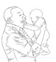  Shows preference,  recognition, and desire to engage with caregivers by reaching, smiling inspecting their faces
12 monthsª | Pulls to stand holding  on to objects  Picks up small objects  using pincer (thumb  and index finger) only | Has one meaningful word  Uses arm or hand to point to people or objects | Uses fingers to feed herself (knows it is food and eats) | Shows recognition of stranger (turns away, stares)
18 monthsª | Walks alone  Holds pencil or stick (in any way) and scribbles on  paper or on ground/floor | Uses at least 2 meaningful words  Understands one simple command (such as “bring shoes”) | Has simple imaginary play like feeding doll, driving cars | Imitates others’ behaviors (waving back, scribbling, washing hands, stacking clothes in imitation)
24 months^{b} | Can run  Makes or copies straight lines and circles | Says short sentences with 2–4 words  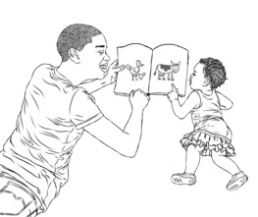  Points to things when they are named | Can follow 2-step instructions | Is more independent, even more defiant
Source: a. WHO (World Health Organization). 2020. Monitoring Children’s Development in Primary Care Services: Moving From a Focus on Child Deficits to Family-Centred Participatory Support. Report of a Virtual Technical Meeting, 9-10 June 2020. pp. 16–17. Geneva: WHO. https://www.who.int/publications/i/item/9789240012479; b. UNICEF (United Nations Children’s Fund). n.d. “Your Baby's Developmental Milestones.” UNICEF. Accessed: March 2, 2021. https://www.unicef.org/parenting/child-development/your-babys-developmental-milestones
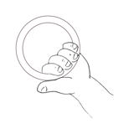  Holds, handles toys or objects  Illustration source: Caregiver Reported Early Development Index (CREDI) | Sits with  support
Vocalizes vowels  “aa,” “uu” | Responds with sounds  when caregiver talks
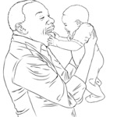  Shows preference,  recognition, and desire to  engage with caregivers  (by reaching, smiling, inspecting their faces) | Brings toys/objects  to mouth
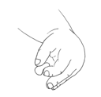  Picks up small objects  using pincer (thumb and  index finger) only  Illustration source: Caregiver Reported Early Development Index (CREDI) | 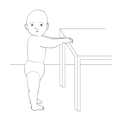  Pulls to stand,  holding on to objects  Illustration source: Caregiver Reported Early Development Index (CREDI)

Has one  meaningful word | Uses arm or hand  to point to people  or objects
Shows recognition  of stranger  (turns away, stares) | 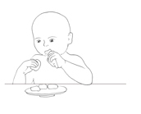  Uses fingers to feed herself  (knows it is food and eats)  Illustration source: Caregiver Reported Early Development Index (CREDI)
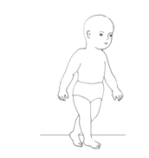  Walks alone  Illustration source: Caregiver Reported Early Development Index (CREDI) | 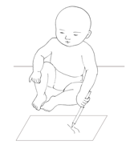  Holds pencil or stick  (in any way) and scribbles  (on paper or on ground/floor)  Illustration source: Caregiver Reported Early Development Index (CREDI)
Uses at least 2  meaningful words | Understands one  simple command  (such as “bring shoes”)

Imitates others’ behaviors  (waving back, scribbling,  washing hands,  stacking clothes in imitation) | Has simple imaginary play like feeding doll, driving cars
Can run  Illustration source: Caregiver Reported Early Development Index (CREDI) | Makes or copies straight  lines and circles
Says short sentences  with 2–4 words | 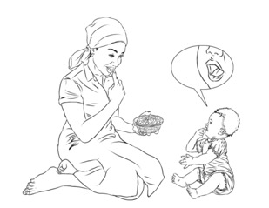  Points to things when  they are named
Is more independent,  even more defiant | Can follow 2-step instructions

Holds, handles toys or objects  Illustration source: Caregiver Reported Early Development Index (CREDI) | Sits with  support
Vocalizes vowels  “aa,” “uu” | Responds with sounds  when caregiver talks
Shows preference,  recognition, and desire to  engage with caregivers  (by reaching, smiling, inspecting their faces) | Brings toys/objects  to mouth
Picks up small objects  using pincer (thumb and  index finger) only  Illustration source: Caregiver Reported Early Development Index (CREDI) | Pulls to stand,  holding on to objects  Illustration source: Caregiver Reported Early Development Index (CREDI)

Has one  meaningful word | Uses arm or hand  to point to people  or objects
Shows recognition  of stranger  (turns away, stares) | Uses fingers to feed herself  (knows it is food and eats)  Illustration source: Caregiver Reported Early Development Index (CREDI)
Walks alone  Illustration source: Caregiver Reported Early Development Index (CREDI) | Holds pencil or stick  (in any way) and scribbles  (on paper or on ground/floor)  Illustration source: Caregiver Reported Early Development Index (CREDI)
Uses at least 2  meaningful words | Understands one  simple command  (such as “bring shoes”)

Imitates others’ behaviors  (waving back, scribbling,  washing hands,  stacking clothes in imitation) | Has simple imaginary play like feeding doll, driving cars
Can run  Illustration source: Caregiver Reported Early Development Index (CREDI) | Makes or copies straight  lines and circles
Says short sentences  with 2–4 words | Points to things when  they are named
Is more independent,  even more defiant | Can follow 2-step instructions

Holds, handles toys or objects  Illustration source: Caregiver Reported Early Development Index (CREDI) | Sits with  support
Vocalizes vowels  “aa,” “uu” | Responds with sounds  when caregiver talks
Shows preference,  recognition, and desire to  engage with caregivers  (by reaching, smiling, inspecting their faces) | Brings toys/objects  to mouth
Picks up small objects  using pincer (thumb and  index finger) only  Illustration source: Caregiver Reported Early Development Index (CREDI) | Pulls to stand,  holding on to objects  Illustration source: Caregiver Reported Early Development Index (CREDI)

Has one  meaningful word | Uses arm or hand  to point to people  or objects
Shows recognition  of stranger  (turns away, stares) | Uses fingers to feed herself  (knows it is food and eats)  Illustration source: Caregiver Reported Early Development Index (CREDI)
Walks alone  Illustration source: Caregiver Reported Early Development Index (CREDI) | Holds pencil or stick  (in any way) and scribbles  (on paper or on ground/floor)  Illustration source: Caregiver Reported Early Development Index (CREDI)
Uses at least 2  meaningful words | Understands one  simple command  (such as “bring shoes”)

Imitates others’ behaviors  (waving back, scribbling,  washing hands,  stacking clothes in imitation) | Has simple imaginary play like feeding doll, driving cars
Can run  Illustration source: Caregiver Reported Early Development Index (CREDI) | Makes or copies straight  lines and circles
Says short sentences  with 2–4 words | Points to things when  they are named
Is more independent,  even more defiant | Can follow 2-step instructions

Holds, handles toys or objects  Illustration source: Caregiver Reported Early Development Index (CREDI) | Sits with  support
Vocalizes vowels  “aa,” “uu” | Responds with sounds  when caregiver talks
Shows preference,  recognition, and desire to  engage with caregivers  (by reaching, smiling, inspecting their faces) | Brings toys/objects  to mouth
Picks up small objects  using pincer (thumb and  index finger) only  Illustration source: Caregiver Reported Early Development Index (CREDI) | Pulls to stand,  holding on to objects  Illustration source: Caregiver Reported Early Development Index (CREDI)

Has one  meaningful word | Uses arm or hand  to point to people  or objects
Shows recognition  of stranger  (turns away, stares) | Uses fingers to feed herself  (knows it is food and eats)  Illustration source: Caregiver Reported Early Development Index (CREDI)
Walks alone  Illustration source: Caregiver Reported Early Development Index (CREDI) | Holds pencil or stick  (in any way) and scribbles  (on paper or on ground/floor)  Illustration source: Caregiver Reported Early Development Index (CREDI)
Uses at least 2  meaningful words | Understands one  simple command  (such as “bring shoes”)

Imitates others’ behaviors  (waving back, scribbling,  washing hands,  stacking clothes in imitation) | Has simple imaginary play like feeding doll, driving cars
Can run  Illustration source: Caregiver Reported Early Development Index (CREDI) | Makes or copies straight  lines and circles
Says short sentences  with 2–4 words | Points to things when  they are named
Is more independent,  even more defiant | Can follow 2-step instructions

Holds, handles toys or objects  Illustration source: Caregiver Reported Early Development Index (CREDI) | Sits with  support
Vocalizes vowels  “aa,” “uu” | Responds with sounds  when caregiver talks
Shows preference,  recognition, and desire to  engage with caregivers  (by reaching, smiling, inspecting their faces) | Brings toys/objects  to mouth
Picks up small objects  using pincer (thumb and  index finger) only  Illustration source: Caregiver Reported Early Development Index (CREDI) | Pulls to stand,  holding on to objects  Illustration source: Caregiver Reported Early Development Index (CREDI)

Has one  meaningful word | Uses arm or hand  to point to people  or objects
Shows recognition  of stranger  (turns away, stares) | Uses fingers to feed herself  (knows it is food and eats)  Illustration source: Caregiver Reported Early Development Index (CREDI)
Walks alone  Illustration source: Caregiver Reported Early Development Index (CREDI) | Holds pencil or stick  (in any way) and scribbles  (on paper or on ground/floor)  Illustration source: Caregiver Reported Early Development Index (CREDI)
Uses at least 2  meaningful words | Understands one  simple command  (such as “bring shoes”)

Imitates others’ behaviors  (waving back, scribbling,  washing hands,  stacking clothes in imitation) | Has simple imaginary play like feeding doll, driving cars
Can run  Illustration source: Caregiver Reported Early Development Index (CREDI) | Makes or copies straight  lines and circles
sssssssssSays short sentences  with 2–4 words | Points to things when  they are named
Is more independent,  even more defiant | Can follow 2-step instructions

Session 11, Learning Objective 2

Training Aid 11.1: Problem and Solution Cards for Children with Feeding Difficulties
Child with Feeding Difficulties Card 1  Problem (8 months) | 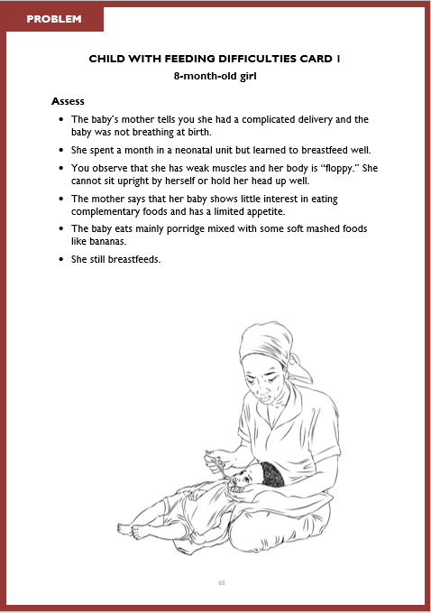 | Child with Feeding Difficulties Card 1 Solution (8 months)
Child with Feeding Difficulties Card 2  Problem (3 weeks) | 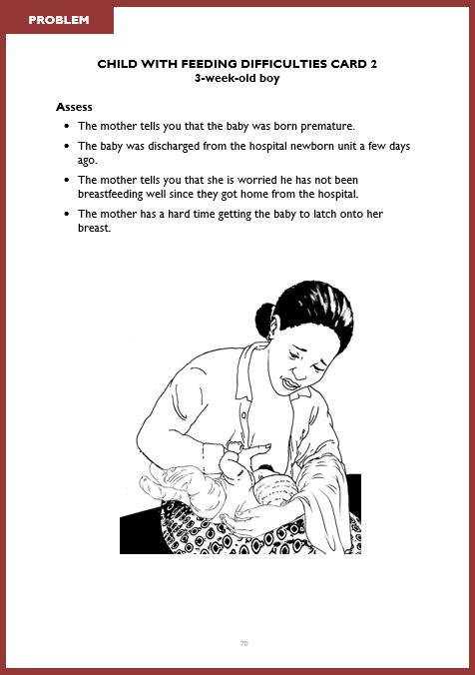 | Child with Feeding Difficulties Card 2 Solution (3 weeks) | 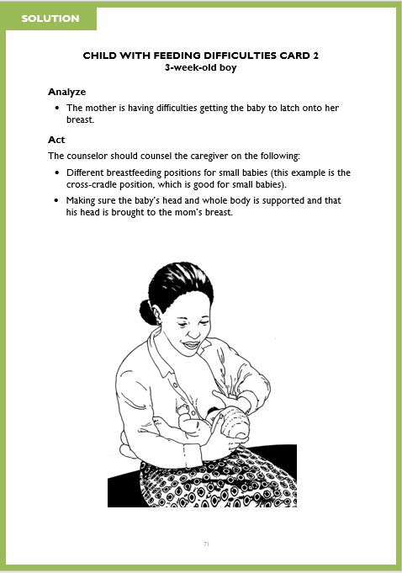
Child with Feeding Difficulties Card 3  Problem (21 months) | 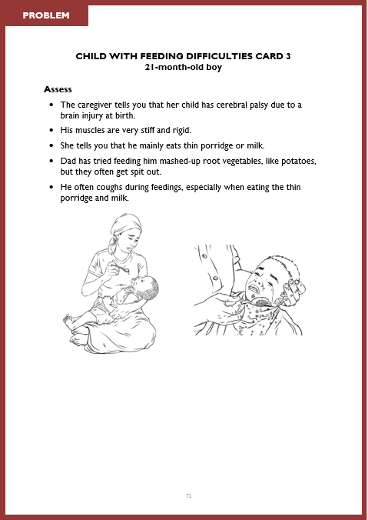 | Child with Feeding Difficulties Card 3 Solution (21 months) | 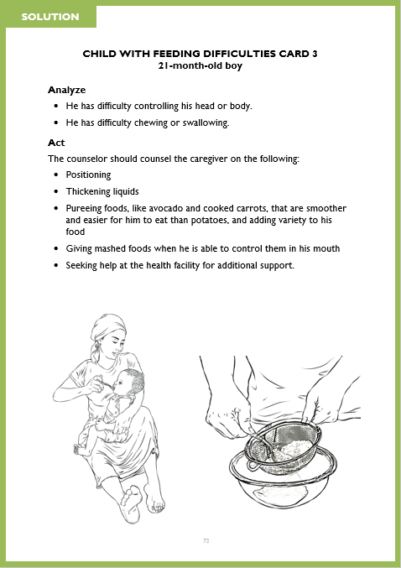
Child with Feeding Difficulties Card 4  Problem (23 months) | 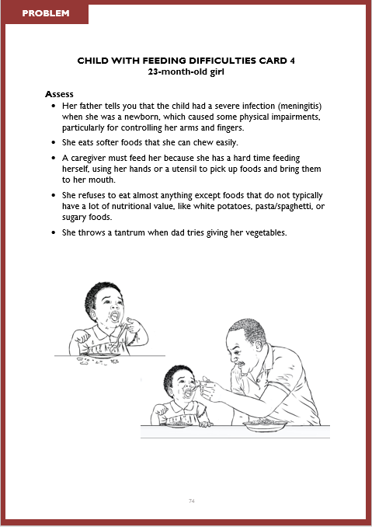 | Child with Feeding Difficulties Card 4 Solution (23 months) | 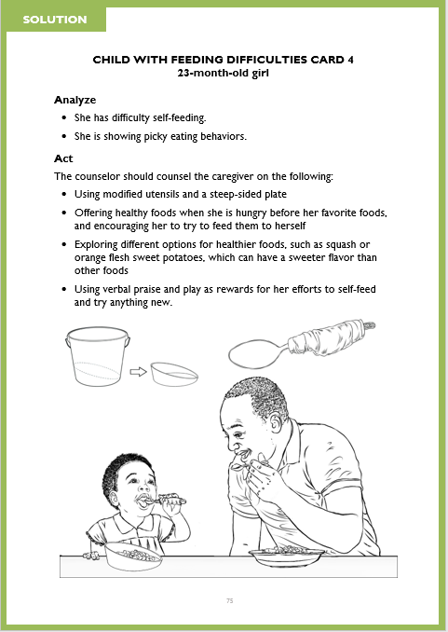
Child with Feeding Difficulties Card 5  Problem (2 weeks) | 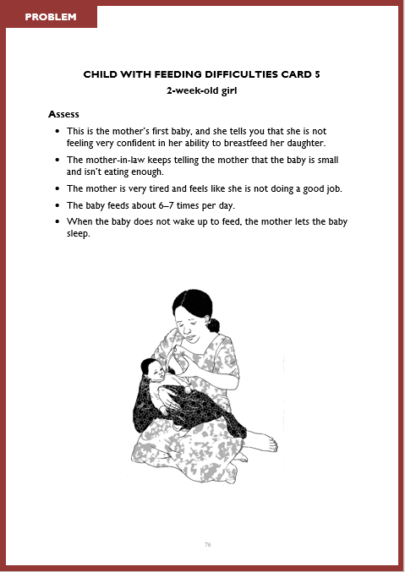 | Child with Feeding Difficulties Card 5 Solution (2 weeks) | 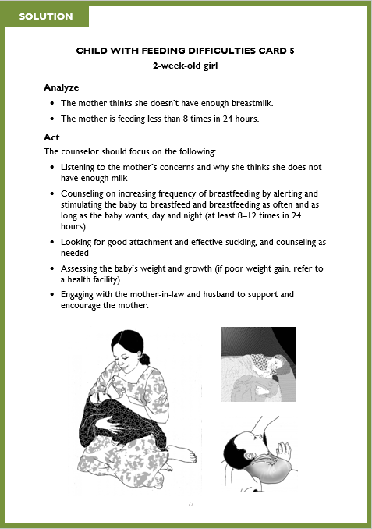
Child with Feeding Difficulties Card 6  Problem (20 months) | 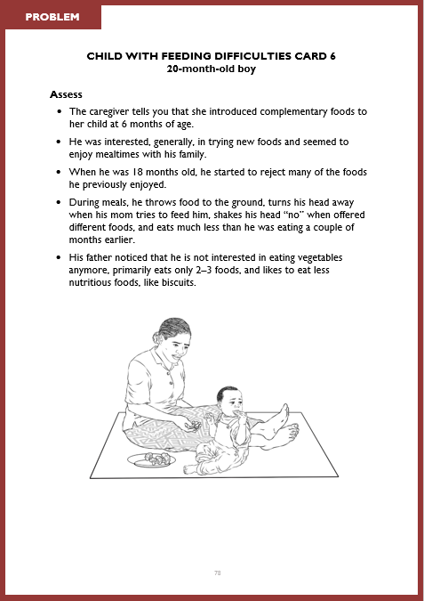 | Child with Feeding Difficulties Card 6 Solution (20 months) | 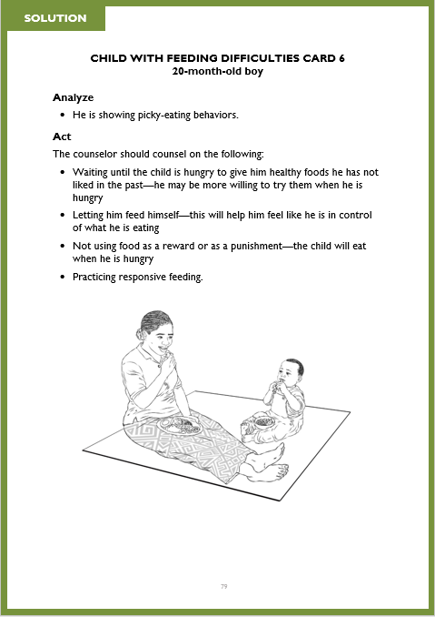

CHILD WITH FEEDING DIFFICULTIES CARD 1
8-month-old girl
Assess
- The baby’s mother tells you she had a complicated delivery and the baby was not breathing at birth.
- She spent a month in a neonatal unit but learned to breastfeed well.
- You observe that she has weak muscles and her body is “floppy.” She cannot sit upright by herself or hold her head up well.
- The mother says that her baby shows little interest in eating complementary foods and has a limited appetite.
- The baby eats mainly porridge mixed with some soft mashed foods like bananas.
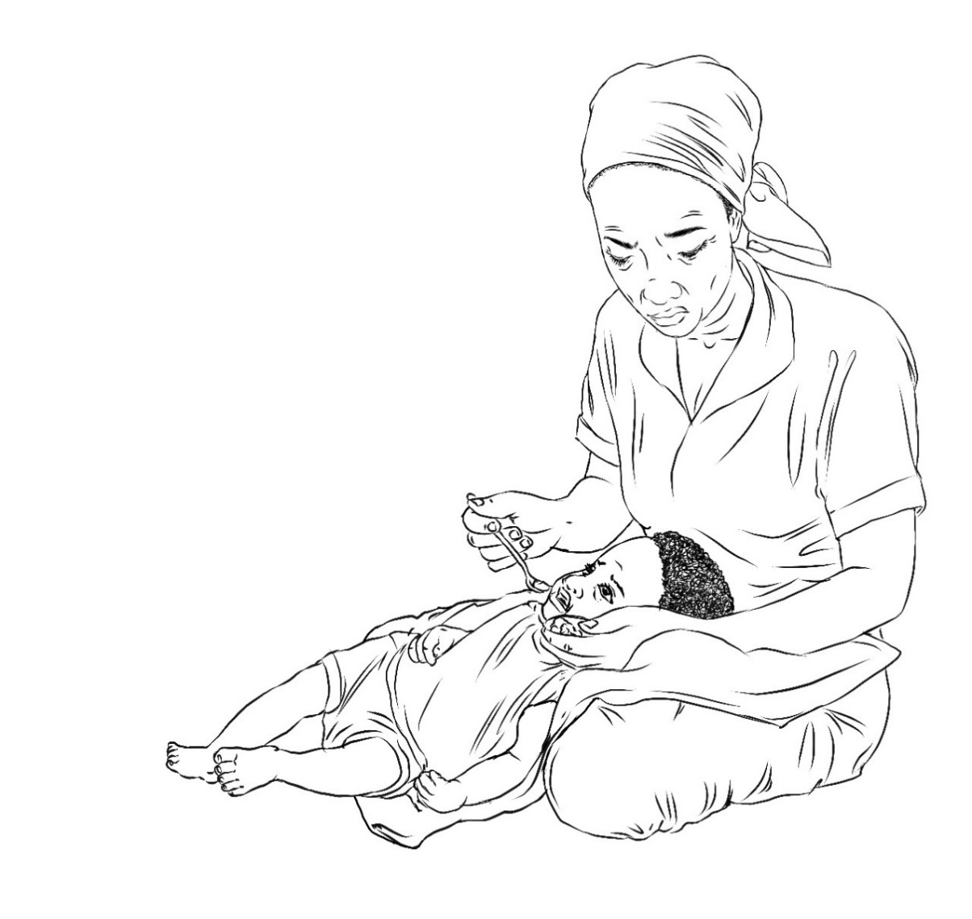
- She still breastfeeds.

CHILD WITH FEEDING DIFFICULTIES CARD 1
8-month-old girl
Analyze
- The baby has difficulty controlling her head and body.
- She has a poor appetite and therefore may not be gaining weight appropriately.
Act
The counselor should counsel the caregiver on the following:
- Positioning
- More frequent, smaller meals spread throughout the day
- Responsive feeding
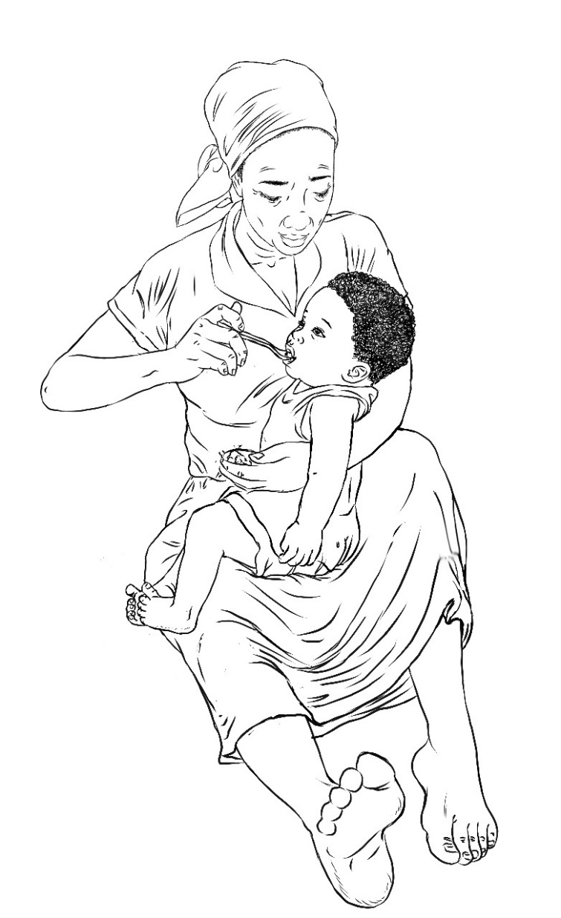
- Monitoring growth and seeking care if the baby is not growing well.

CHILD WITH FEEDING DIFFICULTIES CARD 2
3-week-old boy
Assess
- The mother tells you that the baby was born premature.
- The baby was discharged from the hospital newborn unit a few days ago.
- The mother tells you that she is worried he has not been breastfeeding well since they got home from the hospital.
- The mother has a hard time getting the baby to latch onto her breast.
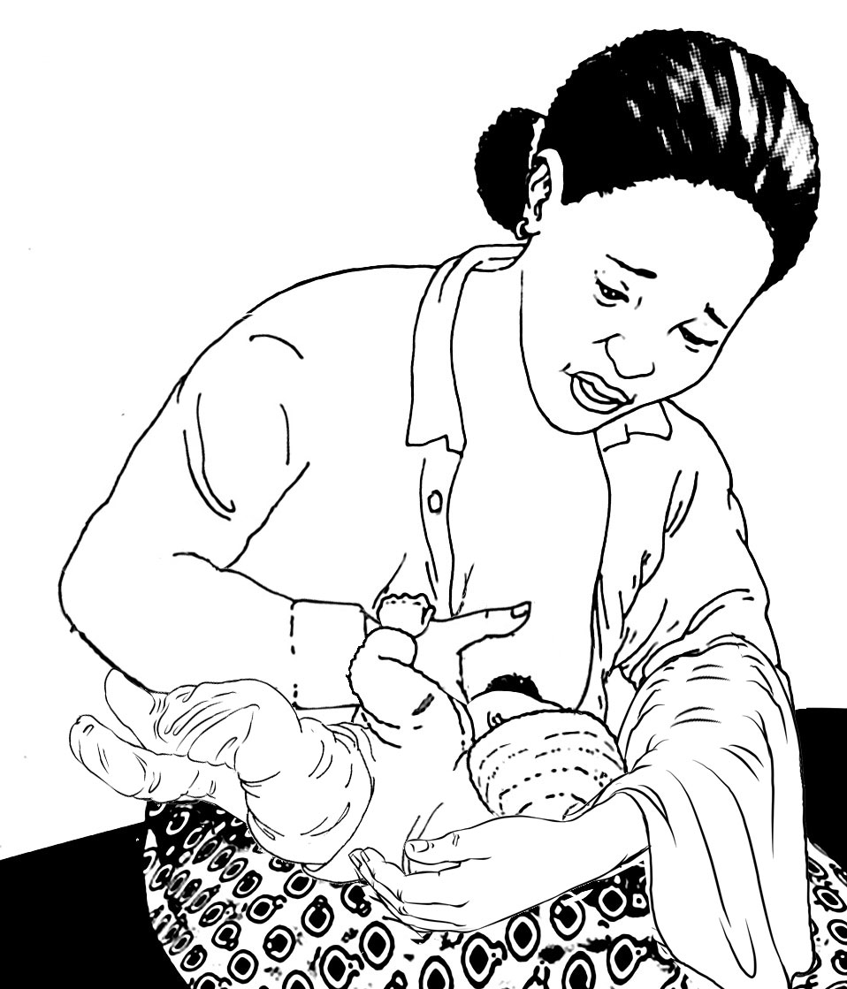
CHILD WITH FEEDING DIFFICULTIES CARD 2
3-week-old boy
Analyze
- The mother is having difficulties getting the baby to latch onto her breast.
Act
The counselor should counsel the caregiver on the following:
- Different breastfeeding positions for small babies (this example is the cross-cradle position, which is good for small babies).
- Making sure the baby’s head and whole body is supported and that his head is brought to the mom’s breast.
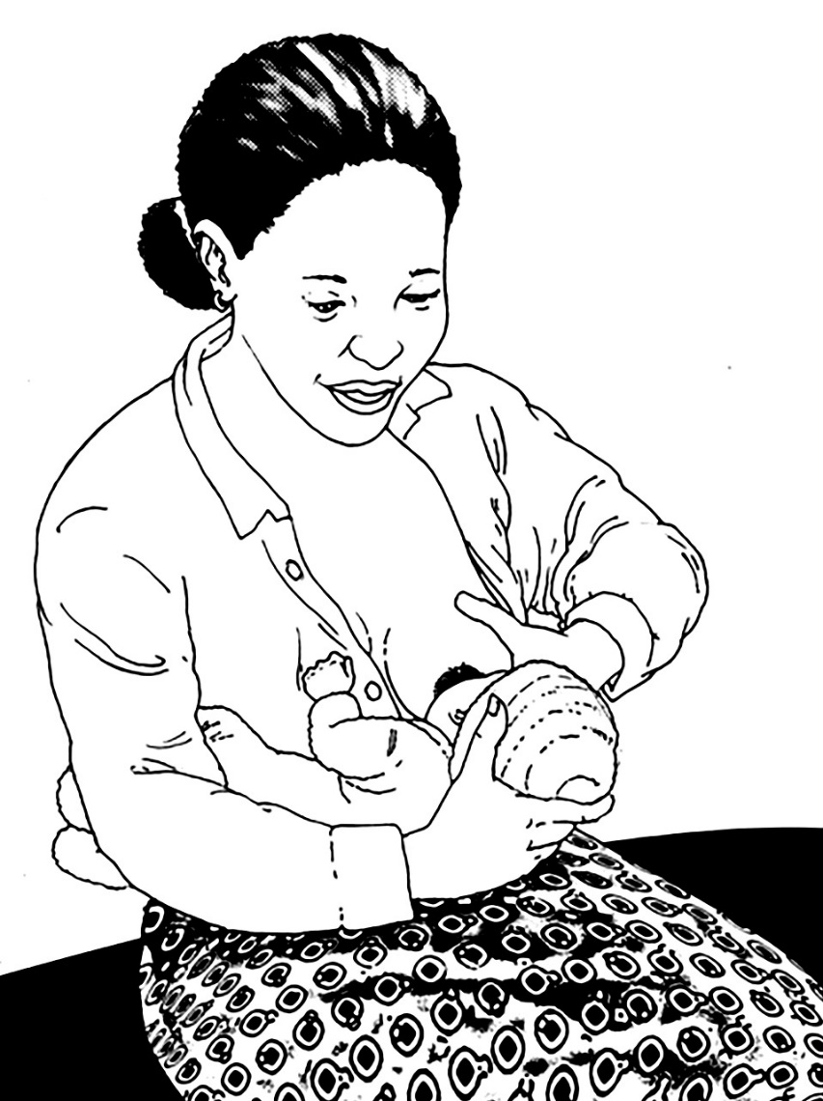

CHILD WITH FEEDING DIFFICULTIES CARD 3
21-month-old boy
Assess
- The caregiver tells you that her child has cerebral palsy due to a brain injury at birth.
- His muscles are very stiff and rigid.
- She tells you that he mainly eats thin porridge or milk.
- Dad has tried feeding him mashed-up root vegetables, like potatoes, but they often get spit out.
- He often coughs during feedings, especially when eating the thin porridge and milk.
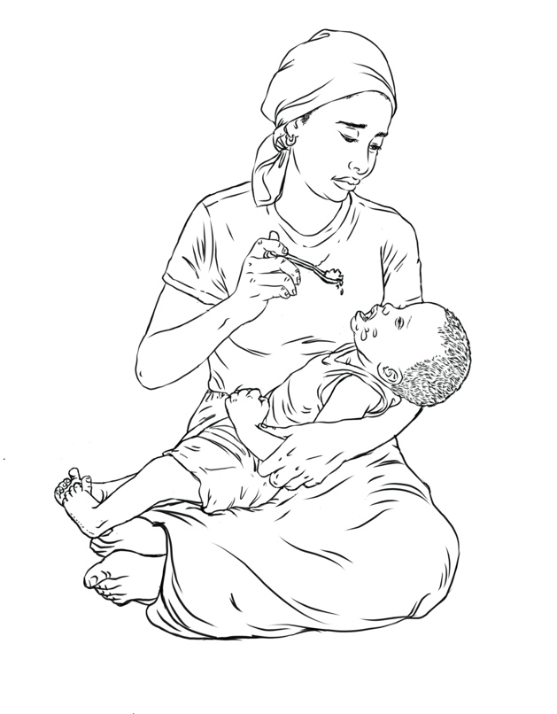
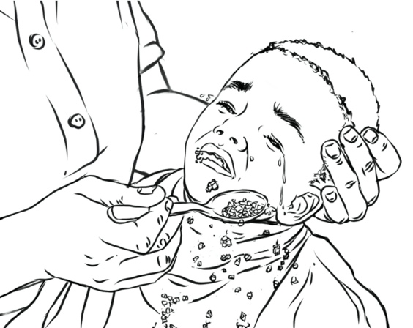

CHILD WITH FEEDING DIFFICULTIES CARD 3
21-month-old boy
Analyze
- He has difficulty controlling his head or body.
- He has difficulty chewing or swallowing.
Act
The counselor should counsel the caregiver on the following:
- Positioning
- Thickening liquids
- Pureeing foods, like avocado and cooked carrots, that are smoother and easier for him to eat than potatoes, and adding variety to his food
- Giving mashed foods when he is able to control them in his mouth
- Seeking help at the health facility for additional support.

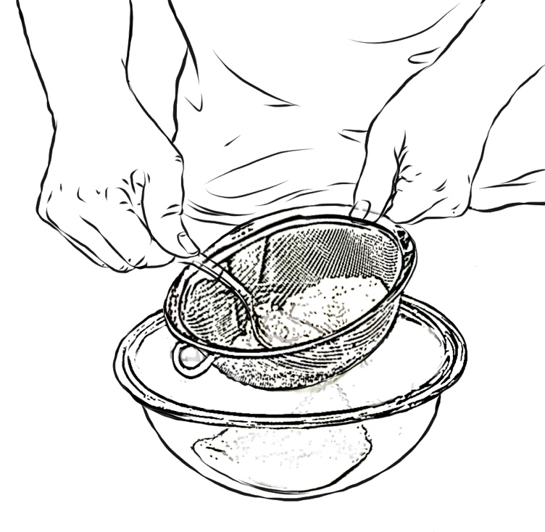
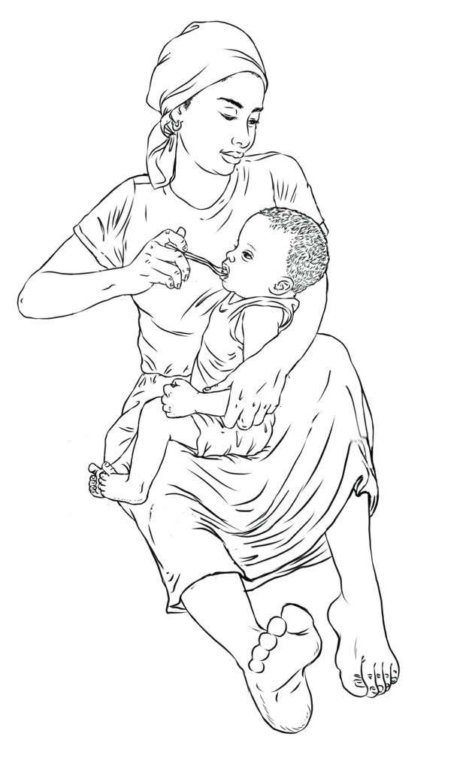
CHILD WITH FEEDING DIFFICULTIES CARD 4
23-month-old girl
Assess
- Her father tells you that the child had a severe infection (meningitis) when she was a newborn, which caused some physical impairments, particularly for controlling her arms and fingers.
- She eats softer foods that she can chew easily.
- A caregiver must feed her because she has a hard time feeding herself, using her hands or a utensil to pick up foods and bring them to her mouth.
- She refuses to eat almost anything except foods that do not typically have a lot of nutritional value, like white potatoes, pasta/spaghetti, or sugary foods.
- She throws a tantrum when dad tries giving her vegetables.

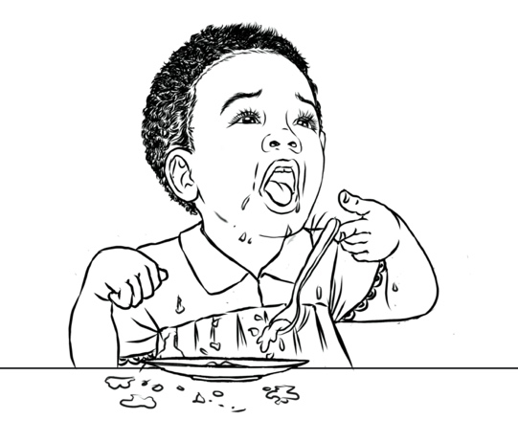
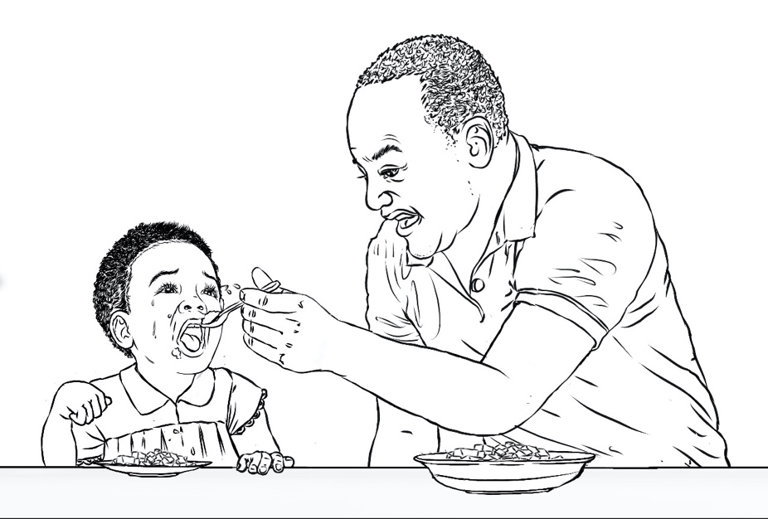
CHILD WITH FEEDING DIFFICULTIES CARD 4
23-month-old girl
Analyze
- She has difficulty self-feeding.
- She is showing picky eating behaviors.
Act
The counselor should counsel the caregiver on the following:
- Using modified utensils and a steep-sided plate
- Offering healthy foods when she is hungry before her favorite foods, and encouraging her to try to feed them to herself
- Exploring different options for healthier foods, such as squash or orange flesh sweet potatoes, which can have a sweeter flavor than other foods
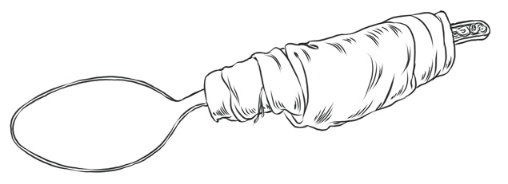
- Using verbal praise and play as rewards for her efforts to self-feed and try anything new.
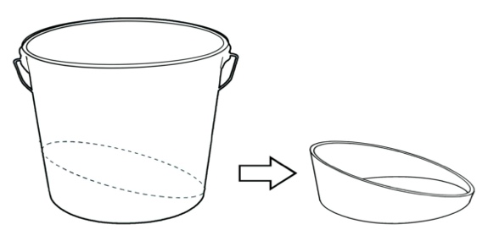
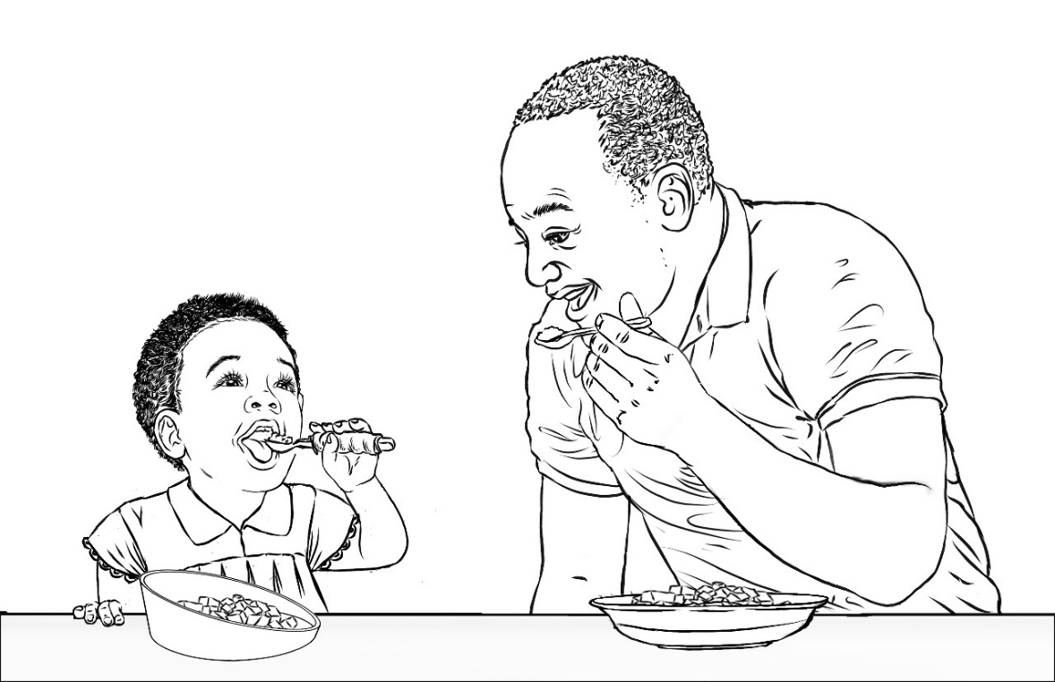
Note: A plate with steep sides makes eating easier for a child who has difficulty self-feeding. A steep-sided plate can be made from a small, clean plastic bucket by cutting the bucket as shown in the image above.

CHILD WITH FEEDING DIFFICULTIES CARD 5
2-week-old girl
Assess
- This is the mother’s first baby, and she tells you that she is not feeling very confident in her ability to breastfeed her daughter.
- The mother-in-law keeps telling the mother that the baby is small and isn’t eating enough.
- The mother is very tired and feels like she is not doing a good job.
- The baby feeds about 6–7 times per day.
- When the baby does not wake up to feed, the mother lets the baby sleep.
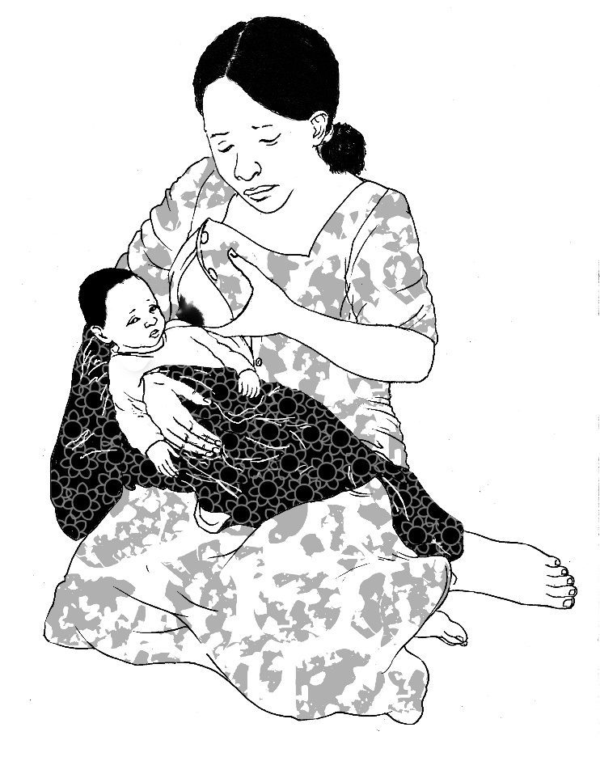

CHILD WITH FEEDING DIFFICULTIES CARD 5
2-week-old girl
Analyze
- The mother thinks she doesn’t have enough breastmilk.
- The mother is feeding less than 8 times in 24 hours.
Act
The counselor should focus on the following:
- Listening to the mother’s concerns and why she thinks she does not have enough milk
- Counseling on increasing frequency of breastfeeding by alerting and stimulating the baby to breastfeed and breastfeeding as often and as long as the baby wants, day and night (at least 8–12 times in 24 hours)
- Looking for good attachment and effective suckling, and counseling as needed
- Assessing the baby’s weight and growth (if poor weight gain, refer to a health facility)
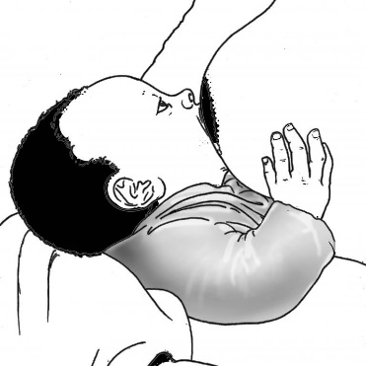
- Engaging with the mother-in-law and husband to support and encourage the mother.
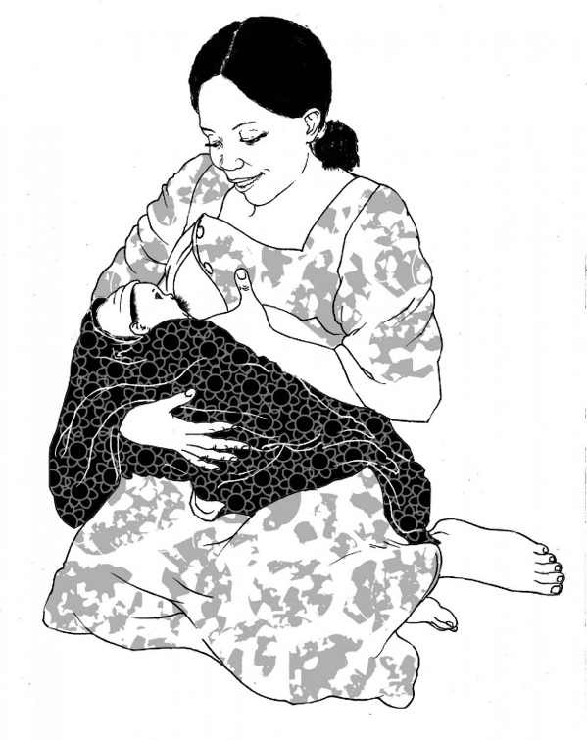

CHILD WITH FEEDING DIFFICULTIES CARD 6
20-month-old boy
Assess
- The caregiver tells you that she introduced complementary foods to her child at 6 months of age.
- He was interested, generally, in trying new foods and seemed to enjoy mealtimes with his family.
- When he was 18 months old, he started to reject many of the foods he previously enjoyed.
- During meals, he throws food to the ground, turns his head away when his mom tries to feed him, shakes his head “no” when offered different foods, and eats much less than he was eating a couple of months earlier.
- His father noticed that he is not interested in eating vegetables anymore, primarily eats only 2–3 foods, and likes to eat less nutritious foods, like biscuits.
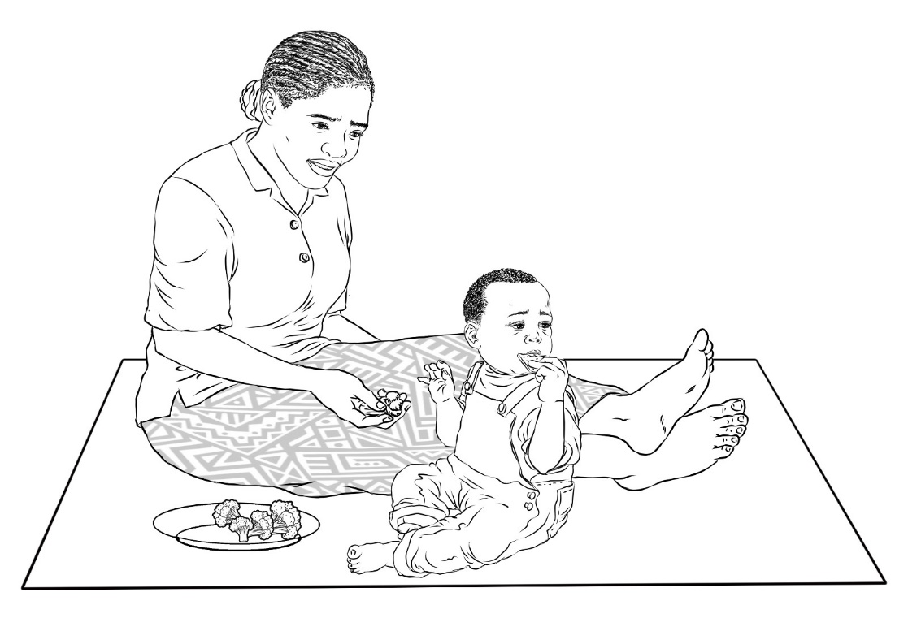
CHILD WITH FEEDING DIFFICULTIES CARD 6
20-month-old boy
Analyze
- He is showing picky eating behaviors.
Act
The counselor should counsel on the following:
- Waiting until the child is hungry to give him healthy foods he has not liked in the past—he may be more willing to try them when he is hungry
- Letting him feed himself—this will help him feel like he is in control of what he is eating
- Not using food as a reward or as a punishment—the child will eat when he is hungry
- Practicing responsive feeding.
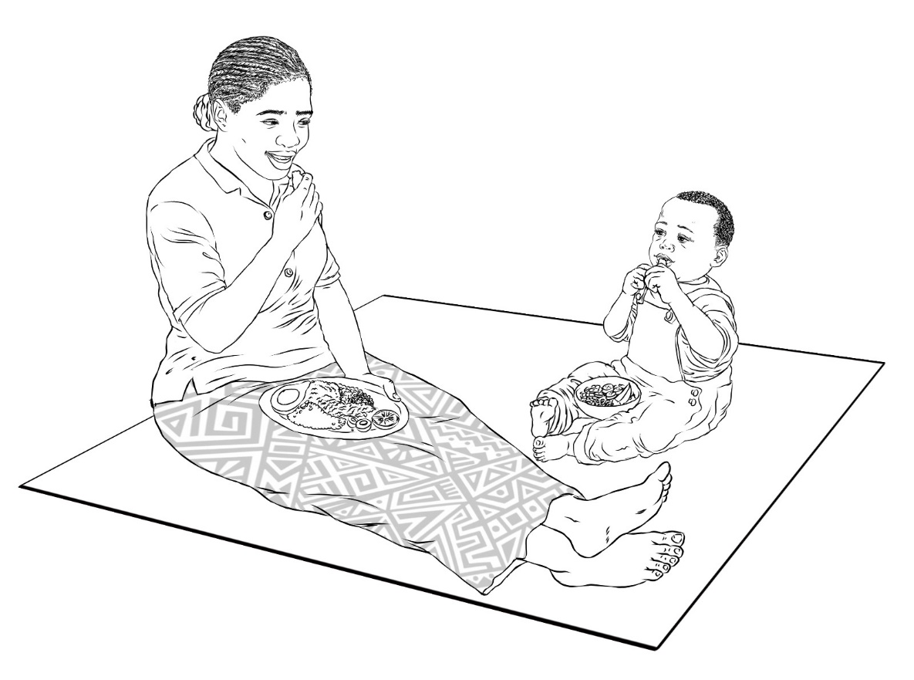

1

USAID Advancing Nutrition is the Agency’s flagship multi-sectoral nutrition project, addressing the root causes of malnutrition to save lives and enhance long-term health and development.
This document is made possible by the generous support of the American people through the United States Agency for International Development (USAID). The contents are the responsibility of JSI Research & Training Institute, Inc. (JSI), and do not necessarily reflect the views of USAID or the United States Government.

USAID ADVANCING NUTRITION
Implemented by:
JSI Research & Training Institute, Inc.
2733 Crystal Drive
4th Floor
Arlington, VA 22202

Phone: 703–528–7474
Email: info@advancingnutrition.org
Web: advancingnutrition.org

June 2023

